Nuclear Commerce – essentials
Politico-military, security, legal and socio-economic aspects
The NPT Regime and its Monitoring of Compliance Mechanisms
Prof. Anis H. Bajrektarevic
and Petra Posega

NUCLEAR COMMERCE- FUNDAMENTALS SECURITY, POLITICO- MILITARY, LEGAL AND SOCIO- ECONOMIC ASPECTS

ABSTRACT:
In an ever evolving and expanding world, there is a constant quest for both more energy and less external energy dependency. With the fossil fuels bound industry setting an alarming trend of negative ecological footprint, there is a clear and urgent must to predict and instruct on alternatives. And, this is the main purpose of this paper. As our key points of argument will show, there is no alternative decarbonized, greener primary energy mix possible in the future without the considerable share reserved for nuclear power. To this end, the development of nuclear power can only be achieved within the current legal framework of nuclear commerce regime. Consequently, we will rethink and revisit some of the fundamentals: the genesis of the world of atoms, applied nuclear science, its military and geopolitical implications, the nuclear commerce regime, legal framework behind this field as well as the factors speeding up or hindering the process of a renewed nuclear power generation, which can be tentatively named a nuclear renaissance. Hopefully, this process will lead to a safe, cleaner, cheaper and decarbonized, greener energy mix in the near future.

Keywords:
Nuclear energy, PEM (Primary Energy Mix), NPT (Non- proliferation treaty), IAEA (Intl. Atomic Energy Agency), nuclear commerce, geopolitics of energy, security, legal framework, green growth

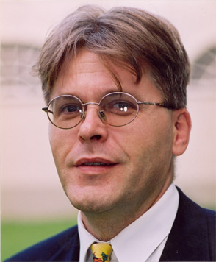 | Anis H. Bajrektarevic  Anis H. Bajrektarevic is a Professor and a Chairperson for International Law and Global Political studies at the Austrian IMC University of Applied Sciences. He is editor of the NY-based Addlton’s GHIR Journal (Geopolitics, History and Intl. Relations), as well as the Senior Editorial member of many specialized international magazines, including the Canadian Energy Institute’s Journal Geopolitics of Energy.  For the past 15 years, prof. Anis has organized dozens of public events by hosting numerous heads of missions to the IAEA and CTBTO, many of them while being in the Board of Governors as members or chairing that key IAEA body. Nuclear issues have been extensively discussed at these public events when professor was hosting ambassadors of the US, Russia, China, France, the UK, India, Korea/ROK, Japan, Iran, Israel, Brazil, Turkey, Egypt, Indonesia, Malaysia, Kazakhstan, Australia, South Africa, Mexico, Argentina, Ukraine, Italy, Germany, Spain, Sweden, and many other countries that use nuclear technology. For the same period, professor also organized some two dozens of study visits for his students to the Vienna and Geneva based safety/security-related organizations (such as OSCE, IAEA, CTBTO, OOSA, ECE, DA Com., ITU, WMO, IRC, etc.)  Contact: anis@bajrektarevic.eu
 | Petra Posega  Petra Posega is a master`s degree student on the University for Criminal justice and Security in Ljubljana. She obtained her bachelor`s degree in Political Science- Defense studies.  Contact: posegap@live.com

Table of Contents

1- Introduction 2
2-The Power of Atoms and Nuclear Physics 3
Nuclear Fission 3
Nuclear Fusion 5
Military Applications of Nuclear Technology 6
The Other Side of the Military Nucleus 12
Primary Energy Mix and Primary Energy Supply with a (double) Environmental Twist 15
5- Changing the Patterns of our PEM- Age of a Nuclear Renaissance? 24
3-Nuclear Commerce Markets and the Future Potentials 30
4-The Nuclear Commodity Market 32
Nuclear Plant Construction- Fundamental Considerations 35
Nuclear Safety 36
6-The World of Atoms and its Legal Framework 39
The International Atomic Energy Agency 39
The Non-Proliferation Treaty 40
7-The Nuclear Commerce Regime 47
The IAEA framework 48
The Zangger Committee 49
The Nuclear Suppliers Group 49
The Wassenaar arrangement 51
UN Security Council Resolution 1540 52
8-Conclusion 52
LIST OF REFERENCES 55

Introduction

As the world keeps developing at an even higher pace than predicted and becoming even more energy dependent in every aspect possible, the supplies to fulfill these demands are crucial for a sustainable future. As anticipated by the International Energy Agency (IEA) our overall energy demands will increase by 44% until the year 2030 – which necessitates both energy efficiency and energy security (reliable energy supply). An energy shortage today (but even more so in the near future) would have dramatic impacts on the states and their economies, due to such a reliance on a steady energy supply. In this mission to keep national energy demands steady, we face two available alternatives: either a production of energy from one’s own available resources or a confirmation of supply guarantees from cooperative countries with greater supply capabilities.
There are many alternatives out there and they all have their positive and, respectively, negative sides. Finding one to replace existing methods which is good for the economy and environment and at the same time proves sustainable and efficient is no walk in the park. The security of energy supply will definitely be one of the key issues in the years to come due to the fact that the current system has not proved itself to be adequate to cope with the rising demand. The world would benefit from a clean and stable energy supply with a low CO2 emission rate, which in today’s situation is difficult but more so applicable with nuclear power (set aside the fact of managing the nuclear waste which will be discussed further on in this paper). With new and more efficient technologies in the pipeline, as well as new deals being signed especially in the developing world, the nuclear industry seems to be approaching a turning point. It will have to prove that it is able to satisfy the national and public energy needs and at the same time convince the public of its safety, which is more important now than ever considering the unfortunate disaster in Japan (Fukushima) in March 2011, which once again casted a cloud over nuclear power after some relatively trouble free years since the Chernobyl accident in 1986.
Therefore, the questions of most importance we seek answers for are:
- Will the nuclear industry be capable of meeting the increased energy demand, decreasing external dependences (especially on the side of OECD countries), and altering our current PEM-s towards de-carbonization?
- Will the Nuclear energy in future be of an acceptable commercial, but also socio-environmental, security and politico-military affordable prize?
- Can the current framework in the field of nuclear commerce function as a suitable non-proliferation tool, especially in the field of double use technology (peaceful and military)?
- Does the current nuclear non-proliferation framework hinder the development of nuclear commerce?

2-The Power of Atoms and Nuclear Physics

The foundation for nuclear physic, similar to other modern science fields, can be found in the classical studies of chemistry and physics, dating back a few centuries. More recently, they are greatly intertwined with modern studies of atom and its structure. This new era for nuclear physics began with 5 interconnected scientific breakthroughs with their respective founders: Crookes, who achieved ionization of a gas by an electric discharge; Thompson, who identified the electron as the one charged particle that is responsible for electricity; Roentgen, who discovered the X- rays; the Curies, that identified the first radioactive material radium and Einstein, who provided the relationship between matter and energy with his theory of special relativity. The practical implications are significant since there are only four basic forces: gravitational, electrostatic, electromagnetic and nuclear. Associated with different types of basic forces is an energy, which can be stored, released, transformed and transferred in natural processes as well as in man- made devices.
There are two distinctive possibilities for creating energy in nuclear physics; the widely used process of nuclear fission and the experimental process of nuclear fusion.

Nuclear Fission

Nuclear fission is the process which takes place in nuclear power and should not be confused with nuclear fusion. The source material which is used in nuclear fission is uranium-233, uranium-235 or plutonium-239, which is retrieved from uranium´s natural state “238”.
DEFINITION Nuclear Fission: “Nuclear fission is the process of splitting the nucleus of a heavy atom (target nucleus) into two or more lighter atoms (fission products) when the heavy atom absorbs or is bombarded by a neutron. Fission releases a large amount of energy along with two or more neutrons. The large amount of energy released is due to sum of the masses of the fission products being less than the original mass of the heavy atom. When a heavy atom fissions, it releases neutrons which can be absorbed by other heavy atoms to induce further fissions. This is called a chain reaction. If each neutron releases two more neutrons from such fission, then the number of fissions doubles each generation.”
This reaction creates energy and in turn generates heat, which in a NPP (Nuclear power plant) can be used to boil water which in turn drives a turbine with the steam created.
Due to the fact that a nuclear power plant is dealing with temperatures of the extreme it is of crucial importance to keep NPP controlled and regularly inspected for any forms of defects and also involving a third party for safety precaution. The accidents in Chernobyl (Ukraine) and Fukushima (Japan) received criticism for being sloppy with inspections.
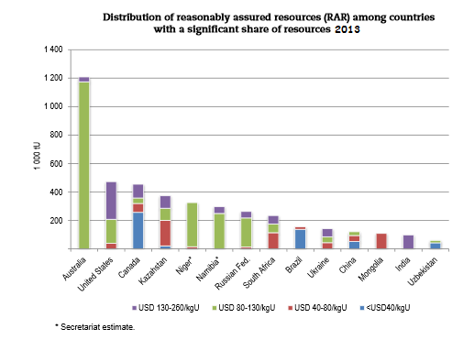
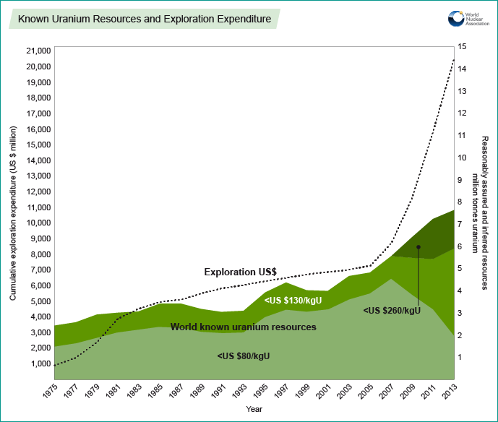

Nuclear Fusion

The concept of nuclear fusion has been a discussion and experimental topic for over 50 years, and consists of creating nuclear reactions between light elements from heavier elements. This concept and its discussed technology has several big advantages, including an almost infinite supply of energy, rather small amounts of mostly short-lived radioactive waste, no possibility of an accident with significant off-site consequences (since the collapse of the plasma at any time would instantly stop the fusion reaction and therefore, would produce no residual heat) and lastly, no concern for the proliferation of nuclear weapons, because there is no requirement for such materials and technologies in nuclear fusion. The very idea of a working fusion reactor solves practically every problem we have with nuclear fission and in this sense perfectly embodies the saying from Jean Monnet. “If you have an unsolvable dilemma, enlarge the context”. However, scientists have yet to construct a self-sustaining fusion reactor. The words of a Nobel laureate for physics, Pierre- Gilles de Gennes, sum up the problem in a very elegant way: “We said we will put the sun into a box. The idea is pretty. The problem is, we don`t know how to make the box.”
The currently most promising experimental fusion reactor is being built in France, called the International Thermonuclear Experimental Reactor (ITER). The project is run by seven member entities- China, EU, India, Japan, Russia, South Korea and the US and is, as mentioned, currently in construction phase, planned to come to an end by 2019. The first full scale fusion tests are not planned to start before 2027 and the project is facing plenty technical difficulties due to the challenging and overwhelming nature of the project. But it is important to remember that if the idea of nuclear fusion is realized, we are looking at practically endless energy source, environment and budget friendly with very little negative consequences.
Nevertheless, despite the many positive and promising sides there are to nuclear power, nuclear inconveniences and the threats they hold are what people most commonly associate nuclear power with. Although this deep-rooted fear is very understandable, if not balanced with information of what NPPs (Nuclear Power Plants) are capable of in relation to other sources of energy the public mass will continue to relate it with:
- Safety incidents such as Chernobyl/UKR, Three Mile Island/USA or Fukushima/JPN.
- Nuclear waste management
- Radiation exposure
- Military applications of nuclear technology and the WMD (Weapons of mass destruction)
- Terrorism through WMD or on NPPs.

Military Applications of Nuclear Technology

Like many other great scientific and technological breakthroughs, nuclear energy has its roots in the military sector. The first CP-1 reactor, built by Enrico Fermi and his colleagues, was a crucial step in what was later known as the Manhattan project. The rest is history. With the introduction of a nuclear weapon to the world the safety of humanity and planet as a whole suddenly became dangerously questionable, since the damage done with the deployment of a nuclear weapon is immensely overwhelming. The development of this weapon came at a great cost, with nuclear testing taking place on the geopolitically less important sites all over the world and escalated to the point where nuclear weapons stockpile dangerously approached the 100 000 limit. After gaining momentum in the midst of the Cold War, the trend of nuclear testing is nowadays on a very insignificant level, especially considering the level it was on some 30 years ago:
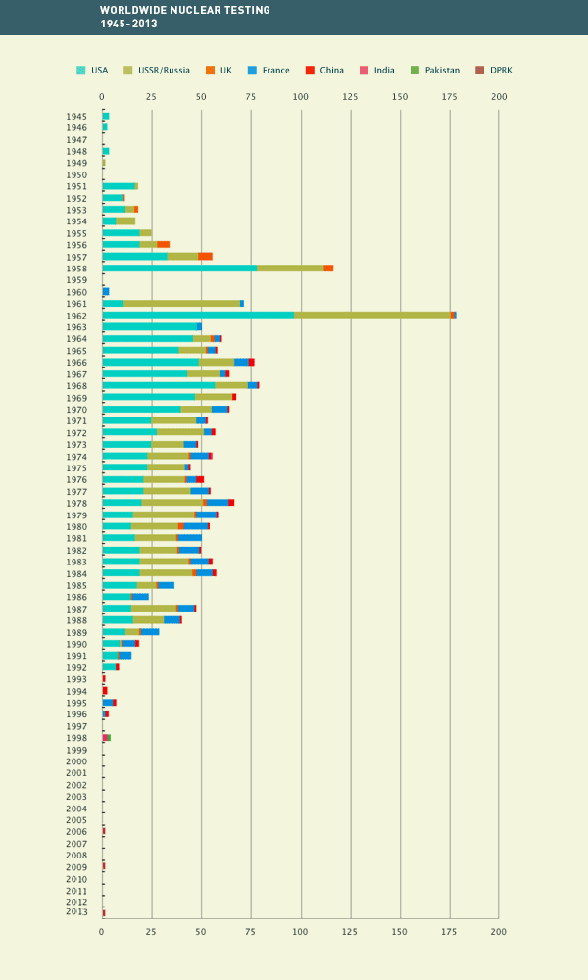

But a decrease in frequency of nuclear testing does not mean that the military side of the atomic energy is becoming any less significant in the contemporary world politics and power play among states. Exactly because of the immense capability of a nuclear weapon this should come as no surprise. But, lucky or not, this capability is also the main driver between two conflicting forces; deterring the political opponents and extreme curiosity when handling threats with this arsenal. Mutually assured destruction (with deliberate or coincidental, but nevertheless very suitable acronym MAD) is a concept nobody should forget, even (especially) past 1991, for its strange balance of fear for mutual annihilation when having sufficient configurations and quantities of nuclear weapons is still very much applicable for the world more than 20 years after the fall of the Berlin wall.
Indeed, the creation of the world’s first nuclear weapon meant a turning point in the international relations and security sector and tensions between Russia and the USA led to the emergence of a cold war. The attacks on Hiroshima and Nagasaki bear witness to the escalating power of modern human weapon technology. We can be sure to say that the nuclear weaponry arsenal was created for one and one reason only: to prevail above everybody. This goes in line with the realistic theory on international relations, arguing that the power of the state is based solely on the brute strength of its own resources, mainly land, people and military capabilities, in a Hobbesian way of struggle of each against all. The realistic theory also introduces a very dangerous concept of absolute security in contrast to relative security, more broadly envisioned in the liberal theory on international relations. Absolute security can, respectively, never be reached, but there are many things that can be done in the name of absolute security, breaching every possible rule, provision or international agreement. This introduces us to the prospective of the constructivist theories, which argue that people give meaning to words, concepts and institutions. And people giving meaning also means people exploiting this in the process.
Concepts of absolute security (along with the concept of means justifying the end) and exploitation of power was clearly seen in the Little boy and Fat man catastrophe and their example has, quite understandably, formed a completely legitimate fear of many people when thinking of the non-peaceful nuclear possibilities. At the moment, these are most commonly associated with contemporary instability in the Middle East, creating regional insecurity due to the fact that Israel and Pakistan are undeclared nuclear powers with many others having clear ambitions (such as Libya, Syria, Iraq, Saudi Arabia, Turkey, and certainly Iran as the most advanced country not just in nuclear technology but also in ballistic missiles). All the periodic disputes between South- and North Korea are burdening the nations of both countries in the highly sensitive and difficult geopolitical neighborhood. The North has become an undeclared nuclear power, of uncertain types, configurations and quantities of the bomb, which additionally burdens the neighbors. All this combined is making confidence building measures conducted by their allies nearly impossible and efforts to achieve it an obsolete undertaking.
Nevertheless, some continue to argue that being a nuclear warhead state generates safety to a country and its people whilst maintaining national pride and extending nuclear protection onto its allies. But one must also take into consideration the political implications and the implications of perpetual nuclear arms race for the international political balance. The best way to avoid an atomic dilemma would be to get rid of the atomic arsenals altogether, something that seems absolutely inconceivable at the moment though, especially considering the aggressive position that US holds regardless of the fact that the Cold War and nuclear race is long over. Or, to quote former US secretary of state Donald Rumsfeld “…the US nuclear arsenal remains an important part of our deterrence strategy, and helps us dissuade the emergence of potential would-be peer competitors, by underscoring the futility of trying to reach parity with us …” Mostly, we would beg to differ the logics of continuous threat perception as good and beneficial for the world but instead argue that nuclear weapons lead to more severe global tensions. Likewise, many states have emphasized that unless and until the world commits itself to complete nuclear disarmament they refuse to end their own nuclear programmes.
Therefore, nuclear deterrence is mostly viewed as a direct cause for the nuclear culture which dehumanizes opponents, exaggerates threats to national security and downplays the consequences for human life and the environment as a whole. Not to mention the effects of test programmes for people living in the South Pacific, centre of Australia and (the allegedly) remote places of US of the former Soviet Union. Also, the aggressive stance has not gone by unnoticed. If we calculate recent global events, highlighting especially the American tendency to control all the major oil and energy flows in the world, establishment of a new network of military bases in Eurasia, updates to the latest technology in the nuclear triad and the B-52 bombers, we can hope that there is no dr. Strangelove that will stop worrying sometime in the future and learn to love the bomb just hard enough.
When it comes to the legal framework on the nuclear weaponry, different international treaties (such as, for example, the START treaties) managed to bound the two most prominent nuclear forces, US and Russia (as a successor to the dissolved Soviet Union) to commit themselves to a world with fewer nuclear warheads and reduce their stockpile for almost four times (although it is questionable how much was this a step out of altruism and pacifism and to what extend was it caused by economic calculations, considering the major expenses connected with maintaining an active nuclear warhead). But nevertheless, as already described in this chapter, we have to consider that a handful of nations are still willing to use these weapons as both threats and deterrent. Considering all this, the nuclear weaponry in numbers today looks as follows:
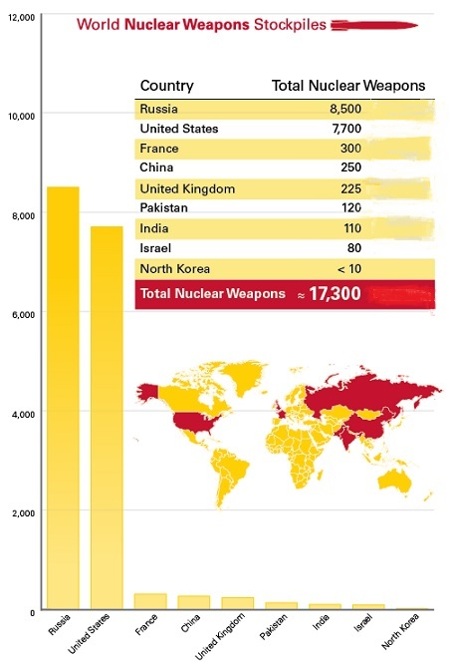

The Other Side of the Military Nucleus

Along with the prominent military application, the peaceful application had also rapidly picked up speed after WWII. As we know, the geographical proliferation of nuclear commerce has to be executed with extreme caution if we want to experience a nuclear boom on a domestic level. Almost every conceivable human activity in the world depends on energy. Only shortages in its supply lead to a self-realization of the dimension currently experienced. To exploit the potential of nuclear energy, there is the previously mentioned differentiation into peaceful and non-peaceful possibilities.
The foundation for an international focus on peace in regards to nuclear power has its core in U.S. President Dwight D. Eisenhower's speech “Atoms for Peace” in 1953:

“I feel impelled to speak today in a language that in a sense is new – one which I, who have spent so much of my life in the military profession, would have preferred never to use.
That new language is the language of atomic warfare”.

After President Eisenhower´s speech The United States launched an "Atoms for Peace" programme which consisted of supplying information and equipment to schools, hospitals and research institutions within the U.S. and around the world. But it is important to understand the non- fabricated, hidden factors behind the pretty facade of this Atoms for peace programme. Although resulting in the more widespread peaceful applications of nuclear technology, its origins could not be more military of geostrategic in nature.
After the US deployed their super weaponry on Japan and terminated two entire cities in order to bring a quick end to the WW2 in the Pacific, the nuclear dilemma of peaceful vs. military became startlingly clear. Very hastily, a commission was established to draw up an international control regime on nuclear power. The immediate result was the Acheson- Lilienthal report that sealed the idea of interdependence and interchangeability of atomic energy and atomic weaponry. The trust in countries worldwide in their intentions was considered not to be implicit and therefore an international regime of control needed to be established. Later on, this report was revised and presented to the UN as the Baruch Plan in 1946, and some of its provisions are clearly still alive in today`s world of nuclear legal regime:
- International control over possibly dangerous atomic energy activities;
- Control would be exercised within an international organization, that would also have mandatory power to control, license and inspect all the peaceful atomic energy activities;
- The international organization would take a vanguard in fostering the beneficial usages of atomic energy.
The preposition was at the time not realized, since the Soviet Union rejected it. Although on the surface everything seemed very altruistic it also meant, consequently, that the US was trying to implement a very rigid system of controls (e.g. by buying up all the available uranium and thorium reserves in order to prevent the mass proliferation). Since the Fat Boy and Little Man had already done its disastrous deed, it was too little too late to play the peaceful gate- keeper to the world of atomic energy. Continuing from this point on, the Soviet Union was trying everything in their power to equalize the stakes set by the US. In 1949 the inevitable happened, when they obtained their first nuclear weapon, realizing the American worst nightmare. Afterwards, the balance of power was set in equilibrium again and the change of strategy was needed to fit more adequately to this new reality. President Eisenhower and his advisers came to the tough conclusion that it is therefore necessary for the US to change its policy of secrecy regarding nuclear power. The Soviet Union was able to gain a major upper hand in the propaganda race from that point on, especially in the Third World (with a big emphasis on the more and more important and, what was considered the worst of all, Communist China). If they decided to break the silence on this strange new power and be the first ones to share its secrets with the world, that could mean a devastating blow for the American influence around the globe at the beginning of the new, post WWII world order. By launching the Atoms for peace programme, Washington was actually limiting the possible Soviet primacy in the Third World countries and their own poor choice of decisions on the matter. Undoubtedly, that meant that certain countries would benefit greatly in the following years by gaining access to the brave new world of nuclear power. One of the beneficiaries of this programme was also Iran that at the time still had a more favorable regime under the Shah. But, as we know, realities in world politics change constantly and it seems that this change comes even faster if you are an US ally.
This trend was abruptly cut short with the Three- Mile Island nuclear plant accident (Later investigations revealed that the critical valves were illegally and manually closed before the accident, preventing cooling water entering the steam generator system of the reactor) because of another, much more important geopolitical game gaining its momentum in world politics.
The origins of this new reality were forged during the Nixon presidency, when the US unilaterally suspended dollar convertibility to gold. This effectively tore apart the essential provisions from the Bretton Woods and introduced the wild floating exchange rates in the world monetary system for the first time. But the dollar currency needed something to make it stable again and this is where the 1973 oil crisis came, seemingly just at the right time. The oil, as we know, has since the beginning been sold in dollars only (for a brief time in British Pound Sterling, too). The shocking skyrocketing prices of crude oil ‘due to the OPEC countries’ triggered shortage of supply have increased the dollar demand for almost 400% at the time. One can see how that affected the standpoint of the Petrodollar on the monetary market. And since many countries in Europe, Asia, Africa and Latin America found themselves paying four times as much for the same amount of oil supply, there came an ever louder talk about an alternative energy source to replace the oil- bound industries.
This is when nuclear energy returned into the international energy spotlight. In the 1970s, many agreements were made between the countries regarding nuclear energy, most notably between Germany and France on the giving end and Brazil, South Africa, Pakistan and Iran on the receiving end. This effectively envisioned the (otherwise ulteriorly motivated) spirit of the Eisenhower`s Atoms for peace programme, meaning the developed countries would help the selected developing countries establish a much more efficient and ultimately, of course, less expensive world electricity generation. But that would, in effect, mean less dollar demand on the market. Combined with other complicated factors, regarding nuclear energy (including the financial and infrastructural overwhelming nature of these projects), that is why the “bloom from the nuclear rose” had to be taken away (and this modus- operandi has repeated many times since then…for example, in November 2000, Iraq along with Iran, Libya, Venezuela, Russia and Indonesia agreed to sell their oil in Euro currency, too. The agreement, sadly, became a dead letter, following the now infamous American attack on Iraq in 2003, that set an example for every country wanting to escape the dollar- dominated crude oil market. In this spirit, we would like to encourage the reader to reconsider the trail of American foreign policy towards the above mentioned countries ever since the year 2000) and that is why every alternative energy option has bigger-than-should-have geopolitical consequences. To put it simply, the mail problem with green/renewable energy is not complexity, expense or lack of technological solutions; the problem lies within the fact that it calls for a geopolitical breakthrough.
Luckily though, not everyone has given up on nuclear (or any other alternative) power, because we have to realize that if we wish a de-carbonized future society there is no other possible scenario without the nuclear energy taking a vanguard in the energy mix. But this will demand a major shift in the global (geo) political mindset, because oil, as mentioned, represents far more than just energy. It represents “socio-economic, psychological, cultural, financial, security and politico-military construct, a phenomenon of civilization that architectures the world of controllable horizontalities which is currently known to, possible and permitted, therefore acceptable for us”. And no matter how optimistic we wish to be, this mindset- shift scenario still seems very unlikely to happen because at the moment, it is very hard to imagine anyone bringing down the American Petro- security, Petro- financial and Petro- military primacy, because all the other major global players are also very Petro- dependent: Russia, Central Asian republics, Brazil, Canada, Mexico, Norway, Venezuela, etc on the supply end and India, China, Australia, South Africa, etc on the receiving end. For now, it seems that humanity has been involuntarily caught in a crude oil vicious circle.

Primary Energy Mix and Primary Energy Supply with a (double) Environmental Twist
Today, nuclear energy holds the 4th place in the total primary energy supply mixture, following the still dominating coal, oil and natural gas holding a staggering 80% of the world primary energy supply. To make this statistics more instructive, we can add that the primary energy supply in 2013 reached 13 217 Mtoe and the final energy consumption stopped at 546,8 Mtoe, which evidently shows that not only is the energy demand still in a steady rise (although very different from the one we experienced in the years 2002 leading up to 2012), we still demand more than we actually consume. This is another factor pointing at the already mentioned obsession of the industrialized world with energy security: reliable/uninterrupted supply, affordable/competitive supply and accessible/available supply. An unhealthy obsession (politically and security wise), combined with the fact that we are no closer to achieving global energy efficiency, is especially sad if we consider that humanity is now in the peak- time of its technological age.
Depending on which country is being discussed, the total energy share provided by nuclear power differs vastly, however within the EU we are talking about a rough number somewhere around 15%, and this number drops to about 6-7% when discussing the world as a whole.
When looking at the figure presented below we notice how sources of energy production have shifted throughout the past 30 years:
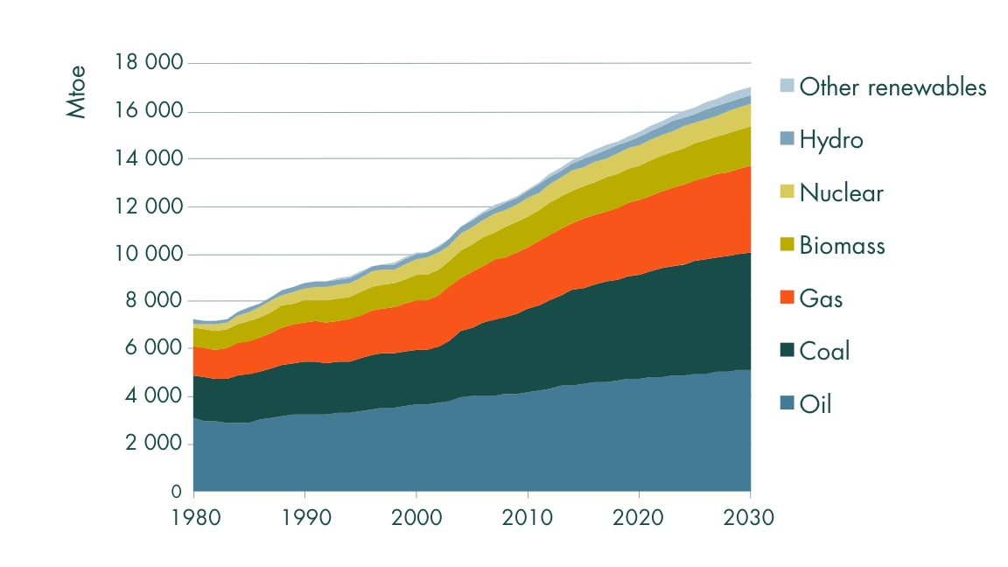

In the future, non- fossil fuels are (according to most predictions) expected to rise globally and the growth is expected to be faster in the non- OECD world. They are still about to be dominated by hydro and nuclear energy, while renewables are yet a mystery as to whether or not they will gain significantly in the energy mix of the future, due to subsidiary costs.
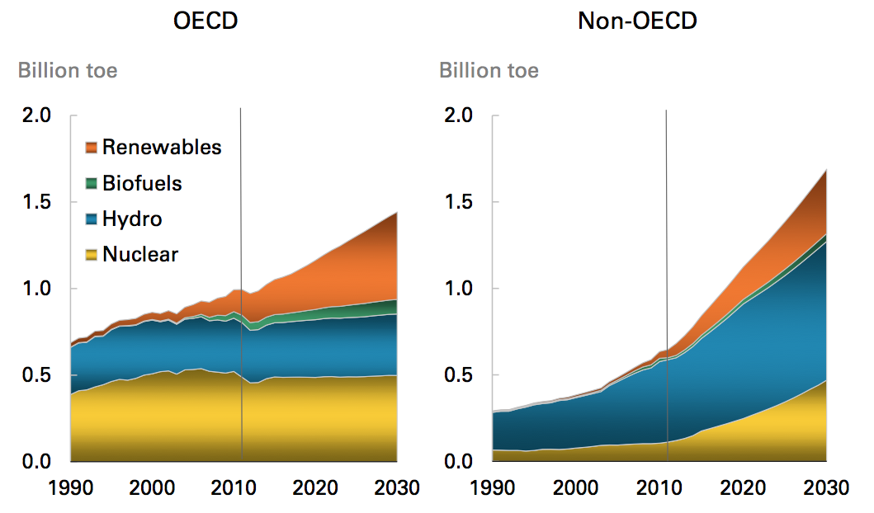

Hence, besides the basic probable course of events, it is very hard to predict how the future of energy production will look like. But hydro, renewable (solar) and nuclear power will definitely have to show their individual strengths as the price for oil continues to rise and we are becoming more dependent on electricity.
The importance of this development is also very crucial because it will play a key role in setting directions for the future of our planet. The current one is applied in the so-called Ecological footprint, arguing that it showcases the difference between our current way of living, especially our consumption and demand, and the planet`s ability to provide for these needs. To put it plain simple, it is (supposedly the right) answer to the question of how many Earths do we need to sustain the current lifestyle of the entire human kind?

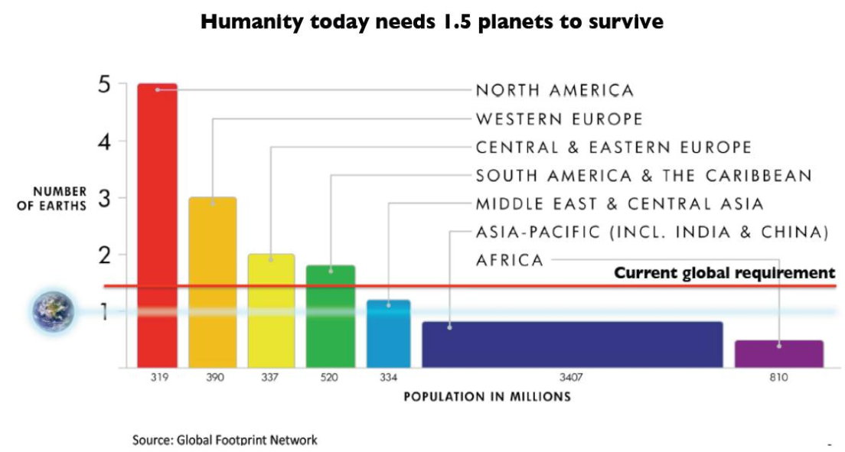
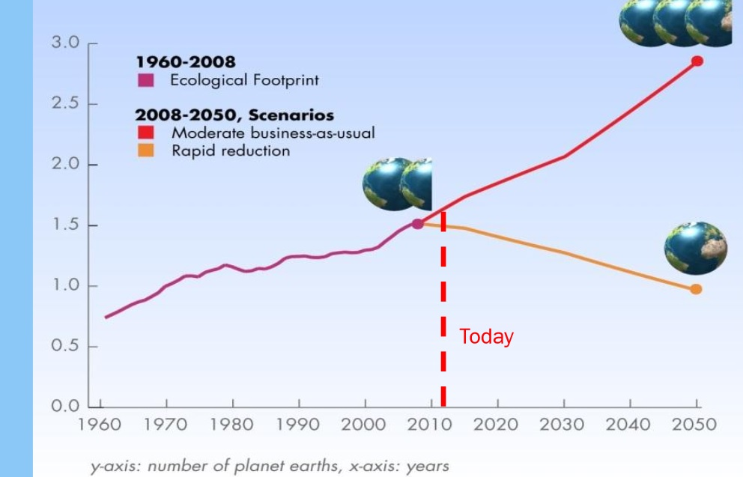
As you can see from the shown charts, they implicate we demand much more than we can receive. However, when striving to perceive such predictions, it is important to keep the focus on the implied word “scenario”. Meaning these are not forecasts, but rather theories, constructed from a collection of different (subjective) assumptions. Well constructed scenarios can be very convincing but it is hard to predict whether or not they will play out the way they were suggested to. Therefore, it is decisive to keep a critical rationale about it and combine scenarios with other available knowledge and solid scientific evidence.
Ergo, we have to be very careful in distinguishing between proper, scientific information versus propaganda and sensationalism. Fact is, that the current lifestyle probably does burden our planet more than it should and a shift towards a different type of energy mix in the future, together with (not so very new) innovations such as the electric car, cannot be considered a bad/idealistic idea, arguably more so because it would also bring a very beneficial geopolitical shift towards a multipolar world. Sadly, as in so many scientific fields nowadays, the global well-being of our planet has turned into a religion, which can as well be called The Global climate change of the latter days. It is not based on concern but on practicality- climate change offers a very strong (and seemingly justified) control mechanism for the global affairs. In this spirit, we would like to incorporate some “warning” charts from the International Panel for Climate Change (IPCC). Not because they are so accurate, because we have to consider that many (scientific and amateur alike) voices consider their report/charts/graphs to be somewhere in between environmental alarmism and environmental sensationalism, but because IPCC (as a reputable international body) has a (larger than should have) impact on the state, corporate and nongovernmental decision-makers around the world.
Accordingly, the most important thing to remember is that these are very inaccurate computer scenarios (not one major prediction has been realized for now). And any serious climate scientists will be very vocal that earth`s climate is a complex mixture of many intertwined factors including solar, cosmic, oceanic, atmospheric and terrestrial. For now, nobody can fully understand the true complexity of this interrelated elements. And while computer climate models can be very helpful in improving our knowledge on concpetual understandings behind major climate forces, they are terrible at actually predicting accuratelly. Least of all computer models from IPCC, because they seem to be blisfully ignorant towards all other important factors save for the human one. The wild inaccuracies and the tendency to politicize are the reason why some authors refer not to the science of IPCC, but to the science fiction of IPCC.

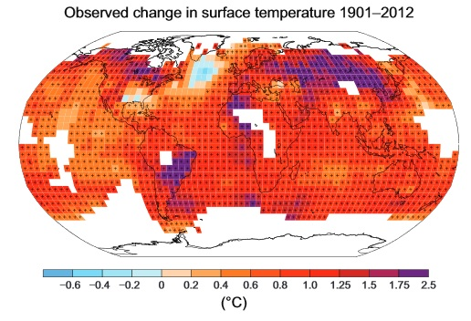

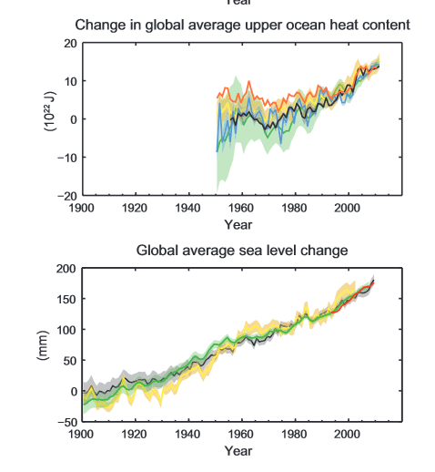 | 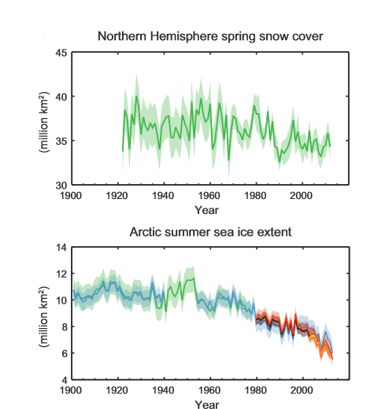

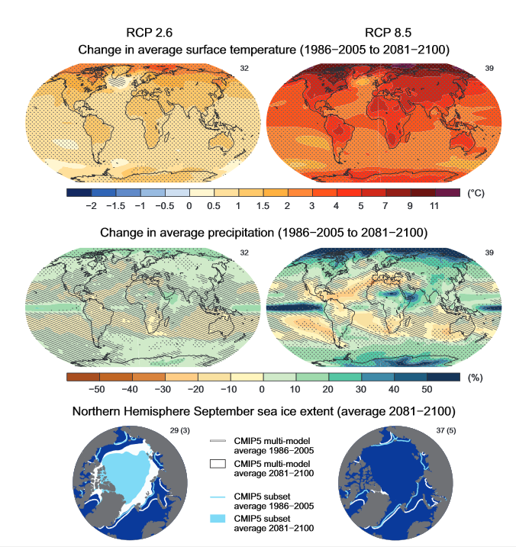

Another, very interesting statistic on this topic is a modern twist on the old UN Human development index (HDI), called the Human Sustainable Development Index (HSDI). The idea is to update the old formula for the HDI (health+ wealth+ education= development) to the new, contemporarily more adequate formula of health+ wealth+ education+ per capita carbon emissions= sustainable development. This twist is due to the fact that development comes at a price and the HSDI shows what is the cost of one country`s quality of life to another`s. And, as expected, the biggest difference in comparing HDI to HSDI happen at the top: notice especially US, Australia and Canada. To put things simply, the lifestyle (inevitably intertwined with development) of people leaving in the poorly rated HSDI states is, at the end of the day, unsustainable. Also, this chart seems to confirm our previous argument that the environmental sensationalism, most notably in the form of IPCC, serves mostly as a control mechanism. Please notice the rank change of US and China; it does serve as a curious fact that we continue to hear that China is the main guilty party for the CO2 emissions, but strangely enough, on the HSDI chart it seems to gain 9 places for their sustainability.
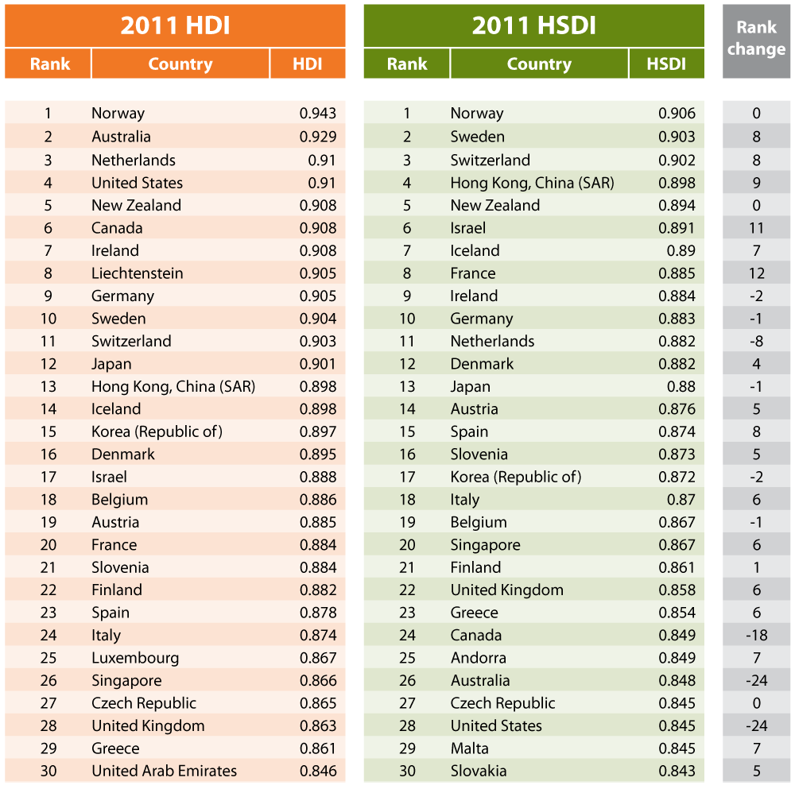
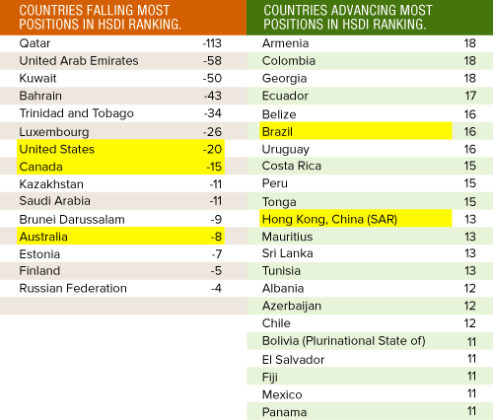
And, to compliment everything written so far, below is another curious index displayed, the Commitment to development index (CDI). It shows the ratio between the capacity of developed states to help the developing countries and the reality of their efforts. It would be nice if this index could serve as a conscience to the developed nations in the world, reassessing the balance between their privileges and their empathy towards the rest, not so privileged world.
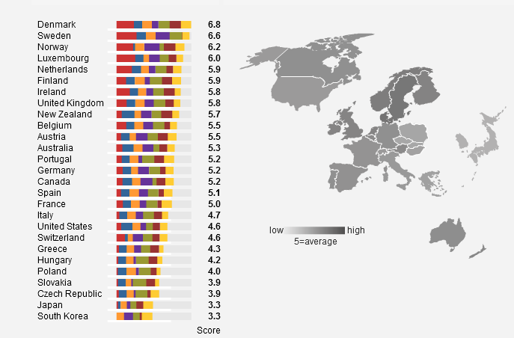

5- Changing the Patterns of our PEM- Age of a Nuclear Renaissance?

Nuclear energy, as discussed in the previous chapter, is therefore not yet displaying its full potential and attaining a better position within the PEM, although it is capable of providing the peoples with CO2 free energy at a low price. The latter, combined with the rising energy demand, is thus the key in the recent trend of renewed interest in nuclear energy. When talking about nuclear commerce in general, one refers to a worldwide trade centered on nuclear energy. Since the mid 2000´s there has been frequent talk about an “atomic renaissance”, due to the market´s energy needs and nuclear power´s capability to meet them. The boom in nuclear power can be seen all over the world in forms of power plants in construction and increased business opportunities taken within nuclear power. China, with 27 power plants under construction and additionally 50 planned, makes it the country with the momentarily fastest growing nuclear industry. (Russia with 10 under construction and 14 planned, and India with 4 under construction and 20 planned).
The last comprehensive analysis on the subject has been published in 2010 by the IAEA and it stated that 65 countries had expressed an interest, were considering or were actively planning for nuclear power, which represented and upward trend from the 51 countries in 2008. However, since the Chernobyl accident, only four countries, Mexico, China, Romania and Iran have started new nuclear programs. On the other hand, Italy, Kazakhstan and Lithuania have closed all of their reactors.
Regardless, the nuclear energy demand appears to still be in the growth phase, only not in the countries where it has been before. Today, there are 30 countries with active civil nuclear power plants and 40% of those are developing countries. Also, the majority of the states planning or proposing nuclear power plants are developing countries. Looking ahead, lower capital costs and simplified operational requirements of the innovative small power reactor designs, currently under development, could make nuclear energy more available. The growth markets for the nuclear energy in the next decade, according to the market experts, will continue to be China, Russia, India and South Korea.
The main obstacles in enhancing and strengthening the position of the nuclear in the overall energy mix are shifts in the political support, struggles in finding the capital needed, market forces, linked to competing technologies, for example gas and renewables, and an apparent global decline in interest for low- carbon technologies. Or, as Bob Evans of the Enercon Services said, the “countries continue to “talk the talk” of carbon dioxide reduction, while being unwilling to “walk the walk” .
The below tables show the current trend in world nuclear energy:

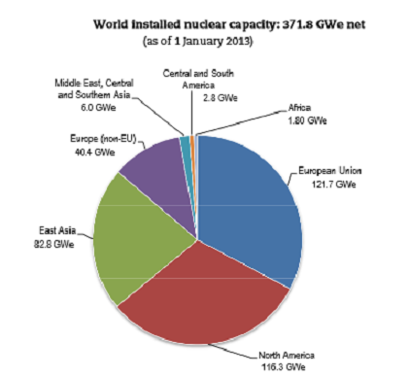
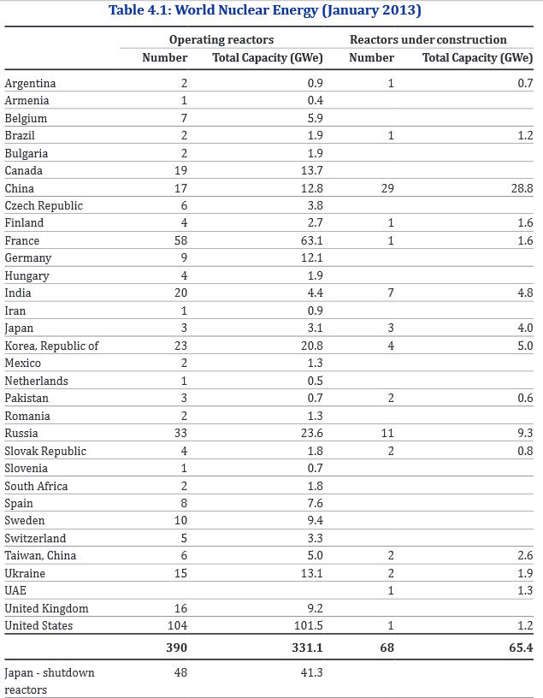
The future of nuclear commerce heavily depends on positive political will which is expected to also help to influence and increase a positive public opinion in time. Sometimes it seems that the resentment and rejection of nuclear energy among people is so powerful, that psychologists call this phenomenon a technological stigma; attributing solely certain qualities to controversial technology that are in essence deviant, imperfect or unwanted. In this process, the bad features of this technology are the only ones that seem to matter; possible positive perspectives are forgotten and seldom reflected upon. This seems to be the case with nuclear technology in general which is regrettable since it offers clear and attaining advantages compared to the current fossil- fueled dominated energy mix; and without nuclear energy, especially considering the presently available technologies, we cannot significantly change our PEM. To omit this trend, in addition to positive political will the shift in thinking will also be deeply connected to technical improvements that will strive towards eliminating possibilities for a large scale nuclear disaster and the effective recycling of nuclear waste. Unfortunately, to this day, no fully satisfactory recycling scheme has been developed.
There has been a lot of discussion lately on the possible usage of californium, a little known fringe element, discovered in the 1950s. Research has proven that californium shows potential for storing, even recycling radioactive waste into fuel, which has been the subject of many heated debates on nuclear power for decades now. There is no doubt that radioactive waste presents a complicated issue within the field of nuclear power and its facilities. Fact is that the process of nuclear decay can take thousands of years to break down into less dangerous isotopes; in the meantime, plenty can go wrong. Nuclear waste has to be sealed in airtight steel or concrete containers; if we consider how much can an average Joe complain for having to sort his waste, respectively, it`s even worse when it comes to nuclear waste. Not to mention that the stockpiles of this waste will become a problem for generations to come, with past weighting on the future.
The thing so encouraging about californium is the fact that it shows signs of extreme resistance against radiation damage; the element can bond and separate other materials, even change the structure of materials stored within it. In this sense, californium could be used to separate different elements in the nuclear waste and therefore recycle the fuel byproducts for reuse in nuclear power plants.
Another propitious research was conducted on MIT, where scientists believe they have found a brilliant way to eliminate nuclear waste. By recycling it into clean electricity, this could power the entire world until 2083. Of course all of this sounds very promising, but future will tell which of the scientific breakthroughs will be applicable for nuclear waste managing. We also have to consider the money and the establishment, running the current business of nuclear waste disposal and storage and the obstacles that can pose for introducing a whole new system of managing.
Other signs which point to a nuclear renaissance are the international co-operations and ambitions taking place between major actors within the industry:
- U.S.-India civil nuclear agreement: In July 2005 India together with the US took a huge step in regards to nuclear safety and cooperation on a global level. India agreed to separate its civil and military nuclear facilities and place all its civil nuclear facilities under International Atomic Energy Agency (IAEA) safeguards and, in exchange, the United States agreed to work toward full civil nuclear cooperation with India.
This was a major stepping stone for nuclear commerce regarding the fact that India has excluded itself from the Non-proliferation treaty, and had previously not cooperated with western countries concerning nuclear power. The Indian government was always especially critical towards hypocrisy of the US, regarding the issue of nuclear restrictions towards South Asian and Middle Eastern states while at the same time permitting the ambitions of Israel, who has avoided any IAEA inspections since the beginning of its nuclear programme. In June 2010, India and Canada (The largest exporter of uranium) signed a nuclear cooperation agreement. This was also an additional positive sign considering Canada has one of the most restrictive legislations regarding its uranium trade.
- Russian & Chinese ambitions: After the fall of the Soviet Union, Russia lost a lot of nuclear influence which it previously had. However, in the past two decades Russia and its two largest nuclear companies (Rosatom and Atomstroyexport) have signed multiple deals with “untouchable” countries like Burma/Myanmar and Iran. This brought forward a new level of global nuclear stability, since Western countries were unsuccessful in reaching the above mentioned states. As for China, having seen an economic boom unlike anything ever seen in human history, the nuclear projects planned are enormous. The public acceptance of nuclear power in China compared to western countries is also a factor which helped the industry grow exponentially.
- EU energy strategy: Given the fact that the European Union imports half of the energy it consumes, it has reached a crucial point in time to plan for means of secure energy supply. In most recent documents, Energy roadmap 2020 and EU nuclear energy policy forecast 2014, nuclear energy is represented as a possible de-carbonized scenario for the future, since the EU is strongly committed to the low-carbon society. Nuclear energy is seen as a “key source of low- carbon electricity generation” and “as a large- scale, low- carbon option, [nuclear energy] will remain in the EU power generation mix” . Still, the greatest concerns are reserved for safety issues and waste management. New technological breakthroughs are seen as the key factor in securing and expanding nuclear share in the EU power generation mix. Besides that, a great factor will also be a change in the European Parliament; with the election, held in 2014, there is a possibility for change in the stance of the politicians in the parliament (considering a very interesting, to say the least, mixture of representatives elected), along with the fact that the Energy Commissioner Günther Oettinger ended his mandate in October, 2014.
Oil imports are reaching record high prices and the EU economy itself keeps wobbling. With foundations such as EURATOM (The European Atomic Energy Community) and the International Atomic Energy Agency (IAEA), with its headquarters in Vienna, it has a major role in informing the public about nuclear power and help meddling between politicians in hopes of further nuclear cooperation between member countries.
Of course, there are also those who argue that the whole premise behind the concept of nuclear renaissance is essentially flawed. They go on to claim that the investments in renewables are on a steady rise and in contrast, the amount invested in nuclear energy represented only one tenth of what was invested in other fields of green energy. They also point out that the number of operational reactors has decreased in the last years, while the “nuclear fleet” is aging with each passing year, with an average age of 25. The statistics shown are also believed to be misleading, since the large number of reactors “in construction” or “in operation” did not produce any electricity in 2009, and many of them represent plans from a different political era, not likely to ever fully materialize. Also questionable in this context is the cost- competitiveness with existing conventional technology, operational safety, radioactive waste disposal and public acceptance. Some from the inside circles in the IAEA concluded that nuclear industry will lose a 11% of market share by 2020, because investors seem to be more interested to fund renewable projects rather than nuclear plants.
Another significant claim is that the continuously interested new markets for nuclear power plants, Asia, are not able to construct and operate such overwhelming projects. Especially worrying are supposed to be meeting the safety requirements, ongoing issues with corruption, the threat of terrorism and civil unrest, the lacking of physical infrastructure needed to support and operate the plant and the financial setbacks.
But despite these critiques and skepticism, reality taking place is hard to deny: the increase in new nuclear projects and political incentives seem to support the claims of a nuclear renaissance. And underestimating Asian markets and the capability and knowledge in that region can never be a smart outlook, even less a strategic consideration.

3-Nuclear Commerce Markets and the Future Potentials
Since the first NPP in 1957, a lot concerning the nuclear market has changed. The Nuclear market has been opened up to private businesses which make the whole commerce procedure a lot easier and more efficient. As a result of the oil embargo on the US, western Europe and Japan, imposed by OPEC (Organization of the Petroleum Exporting Countries), the opportunity for nuclear power expansion was tremendous to be set free from their dependence on oil. In theory, there has been a huge capability for nuclear power leading up to today, and the reason it struggled is due to all the legal and political barriers as well as very strong lack in public support. (Except France with a nuclear energy supply rate of 75-80%; this is due to strong political and governmental support). At the end of the day a lot of it comes down to economics and sustainability. In other words; which methods are most cost efficient and least damaging?
Reasons for why nuclear power is an attractive source of energy can be explained by four main points of argument:
- It offers a stable supply of energy in times where the demand is increasing and other alternatives are not developed enough or too expensive.
- The NPP today are Generation III power plants and the new reactors have evolved tremendously, with larger capacities, (even) lower failure rates and the economic figures are constantly improving.
- Its increased momentum for business.
- Classed as a green energy, i.e. provides energy without interfering with climate change, as shown in the table below, displaying greenhouse gas emissions by electricity generation:

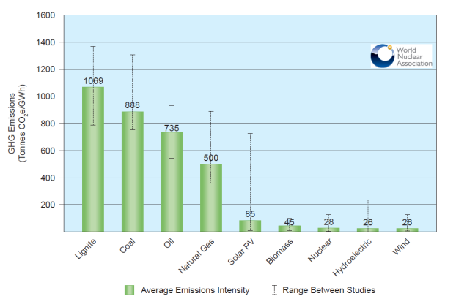

As of 2011 (World Nuclear Association)
Obviously building a nuclear power plant is a huge project and requires large sums of money which have to be invested upfront, while carrying a risk for 30-60 years. Once done, the plant requires operation/maintenance costs as well as nuclear fuel cycle costs (Uranium), however a large portion of the price set by NPP together with energy companies are to large extents made up from the decommissioning expenses as well as the future plant shutdown price.
The danger that a NPP is linked with is an obvious but very important fact, especially concerning professionalism of on-site workers as well as inspection professionals. Reservations regarding nuclear power have their focus on the threat of a nuclear accident, insurance cover and decommissioning of outdated NPPs and waste management.
The result of the tsunami in Japan (Feb. 2011), which severely damaged the Fukushima power plant, occurred at a very sensitive moment of time for nuclear development and its industry. At a point when nuclear power was entering a “renaissance” and had upheld many trouble free years, a rain of negative media hit the industry. Many of us started questioning nuclear power (once again) and the incident also startled East Asian and South-East Asian countries which are located in the same earthquake troubled zones. However, they have not interfered with current nuclear projects (a total of 110 which are planned/under construction) because of the setback in Fukushima:
- In Japan, the new government is re-evaluating the decision of their predecessor on phasing out the nuclear programme,
- Chinese government announced the replacement of the planned Generation II reactors with the improved Generation III reactors, which will meet the safety requirements but slow down nuclear expansion in the country due to higher costs,
- India has affirmed plans for boosting the nuclear capacity by 2032,
- Taiwan, South Korea and Vietnam are proceeding with their announced plans,
- Malaysia is considering the option for nuclear power,
- Thailand and Indonesia have delayed their nuclear programmes, but most likely because of high costs.
Although the long-term impact of the Fukushima disaster on the nuclear programs is not yet clear, the predictable consequence is likely to be the rise in costs due to more rigorous safety requirements and an increase in finance costs, reflecting lenders` reassessment of the commercial risks.

4-The Nuclear Commodity Market

According to the World Nuclear Association (WNA), the commercial worldwide demand for uranium is around 68 500 tons of uranium per year.To simplify this, one must understand that USA (with its 104 NPPs) has a demand of 18 816 tons per year, which corresponds to about 28% of the world market. Again it is the OECD with the NEA which provides account of the Uranium reserves in the form of their so called Red Book, a biennial report on uranium reserves. Canada, who has been by far the biggest supplier with some 11,500 tons of U-3O8 per year until 2009, has been replaced by Kazakhstan that produced a staggering 21 300 tons in 2012. Both countries are followed by Australia, Nigeria and Namibia. The table is surprising, considering that Australia holds the largest known recoverable resources of Uranium, 31%. Also worth mentioning is that among uranium-exporting countries, Australia and Canada have some of the strictest conditions relating to the use of its uranium. These safeguards (inspections and accounting procedures) ensure that exported uranium is used for peaceful purposes only and is not diverted for military purposes or used in a way which adds to the proliferation of nuclear weapons. This tells us that there is a possibility for a nuclear commerce framework that serves as an efficient non- proliferation tool.
Further on, United States as well as China and India rely mainly on imports, thereby neglecting any more extensive domestic production.
As for the companies engaged in this field, it was again the 1990’s that brought movement into the market. Cancelled nuclear energy related projects paired with low uranium price pushed profits down to a level that made any new involvement quite unattractive. The consequence was a takeover and consolidation wave, leaving 8 different enterprises with a combined world share of 81 percent. The big three, namely Cameco(15%), KazAtomProm(15%) and Areva(14%) alone make up for half of the worldwide extraction.
Although the nuclear industry has a steady supply of uranium resources, companies have been relying on current mine sites and current resources. The demand for uranium has in no way been a linear curve throughout time. During post WWII times as well as during the cold war excavation rocketed, and for the time in between and after we notice a remarkable decrease.
The first available option for the nuclear market would be to increase the number of existing mines. This is crucial if we seek a rise in nuclear power in this century. However, this also poses a problem for investors wanting to partake in nuclear power due to the long time-lapse of twenty years from the day of discovery to the start of production. However, searching for uranium is in a way much easier than for other mineral resources because of the radiation signature from uranium`s decay products that makes these deposits identifiable from the air.
The second option would be to extract the huge amounts of enriched uranium and plutonium stocks from nuclear warheads, which is not an easy task. Nevertheless, a major secondary supply of uranium is already provided by the decommissioning of nuclear warheads by the USA and Russia. Since 2000, 13% of global uranium requirement has been provided by this ex-military material.
In the years 2005-2007 the world witnessed a uranium price bubble taking place. This coincided with significant rises of stock price of uranium mining and exploration companies. Luckily for the nuclear commerce and its market the price per pound for uranium stabilized to a fairly “normal” price in 2010.
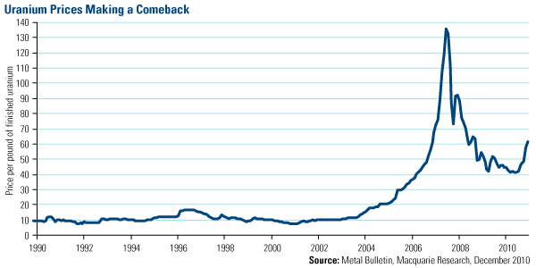

Thorium is a possible alternative source of nuclear fuel, but the technology for exploiting it is not yet established. Thorium requires conversion to a fissile isotope of uranium in a nuclear reactor. However, supplies of thorium are abundant, and the element currently has no commercial value. Accordingly, the amount of resource is estimated rather than directly measured, as with uranium. And although the benefits of thorium often appear overstated, there seems to be some great theoretical advantages regarding primarily sustainability, reducing radiotoxicity and reducing proliferation risk. The greatest interest for developing thorium fuel cycle is visible in India and China; India has major thorium reserves and the possible use of thorium reactors has been under discussion there for decades now. However, the Indian estimate is that about two decades of research and development are needed to assess the performance of thorium reactors, before replicating the initial prototype. China`s interest in thorium is quite new, but nevertheless has started a substantial research programme on the subject. In January 2013, there were 150 PhD scientist already working on the project. Because of the vast thorium reserves, China has a possibility of powering their electricity on thorium basis for generations to come, given the results in the field prove promising.
The complexity and gravity of an industry like atomic power is seldom left entirely to a free and liberalized market. Because of political frictions between the global superpowers, they have developed their own enterprises. Quite naturally, an international takeover in the reactor business is a very sensitive topic for most countries as it poses a question regarding national security.
While traditional theories argue that stiff competition generally provides for incentives to innovate, the sheer magnitude of nuclear projects and the strict legislative framework around it makes it very hard for smaller enterprises to enter the industry. The nuclear industry could definitely benefit from a more liberal market in terms of innovation and progress.

Nuclear Plant Construction- Fundamental Considerations
The sector of nuclear power plant construction is the most important area for future innovation and development, and it is also the area that has seen most changes within the nuclear industry over the years. Expertise in the industry is the key to success, and the demand for educated and professional engineers cannot be too high. The world has yet to see a nuclear power university, which could aid the industry tremendously. The current market leaders, which “dominate” the nuclear industry, are:
- AREVA – French/German
- Atomenergoprom- Russian
- Cameco- Canadian
The biggest issue companies have to deal with when constructing a NPP, is that every new plant is treated as a completely new case. This makes the whole process a lot more time consuming and expensive as companies make their way through the bureaucratic jungle that surrounds this business.
There are plans for constructing Generation IV power plants, designed to offer higher levels of safety, economics, non-proliferation and sustainability than the current Generation III. An international cooperation framework, known as Generation IV international forum (GIF) has been set up to establish a platform for creating systems, identified as most promising. The generation IV systems are expected to enter into force in estimated 20 years.
Another innovation in the field is an idea for Small Modular Reactors; the adjective “small” standing for the electrical power input that should not exceed 300 MW, which is a significant decrease from large Generation III reactors currently used. Other advantages of Small Modular Reactors would include a high level of modularity in design and construction and the possibility to expand them with adding modules to generate even as much power as a larger reactor. Successful development of the Small Modular Reactors could attract new countries to the nuclear club, who do not need the size and/or do not have the means to finance the costs of conventional 1,000 MW and larger plants. These ideas could prove very promising in a sense of making nuclear power more socio- economically suitable for the interested parties.

Nuclear Safety

Nuclear safety stands for the process of eliminating unintended conditions or events that lead up to radiological releases from the otherwise legal and authorized activities. Nuclear safety is closely linked to nuclear security and nuclear safeguards, although we have to distinguish the three:
- nuclear safety covers the activities aimed at preventing nuclear and radiation accidents or to limit their consequences in the management and activities of nuclear power plants, other nuclear facilities, transportation of nuclear materials and the use/storage of nuclear materials for uses in the fields of medicine, power, industry and military (although the oversight on military nuclear programs is usually executed by different agencies than those operating in civilian sector),
- nuclear security stands for preventing international misuse of nuclear and other radioactive materials by non-state actors to cause harm, mainly by enhancing security at the nuclear power plants and in the process of transportation of this materials,
- nuclear safeguards are focused on restraining the activities of (primarily, but not exclusively) rogue states that could lead up to acquisition of nuclear weapons.
The most extensive fields to cover when it comes to nuclear safety are without a doubt the safety of nuclear power plants and the safe management of nuclear waste material. This importance also results in the fact that these two issues are the most politicized themes in the nuclear safety field. When it comes to power plants, statistics show that only three major nuclear accidents happened in over 15 000 cumulative reactor years in 33 countries, concluding that nuclear power plants are a safe way to produce electricity. In the below table, five- level approach to maintaining safety at a nuclear power plants is shown:
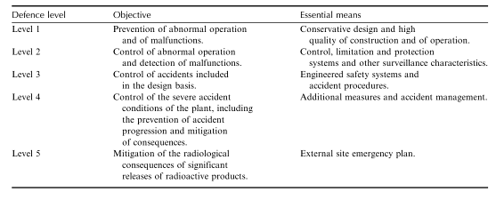
Unfortunately, like in the aviation industry, there can be a lot of bad publicity regarding nuclear safety and its accidents, and not enough evidence- based facts and conclusions. This was also visible in the latest nuclear power plant disaster in Japan. The authors of a book on the subject, Fukushima: the story of a nuclear disaster, sum up this matter very well by saying: “There are lessons to be learnt from what went wrong at Fukushima. There are equally important lessons to be learnt from what went right”.
An auditor for global nuclear safety is the IAEA, which prescribes safety procedures and has since obtaining this role established a system of reporting even the most minor accidents that occur. State safety inspectorates for nuclear power plants also work very closely with the agency and these activities only enhance the importance of the role that the IAEA has today.
In the nuclear safety field, there is also a great and important role reserved for state and non- state actors on a national level. State and local governments, local watchdog groups, concerned citizens and the media all play a significant role in obtaining, enhancing and maintaining nuclear safety.
An additional important aspect of nuclear safety is the human factor, therefore the relationship and mismatch between human and technology. The human factor analysis offers an insight into human capabilities, characteristics, limitations, behavior patterns and motivation. In nuclear safety the human factor can be visible on the macro-level, with the wrong decision- making process at the time of nuclear accidents but also on the micro- level in reduced productivity and the on-site demeanor that endangers employees` health. As a result of such crucial importance to adhere to safety procedures and protocols, there is an emphasis on the human factor in design, operation, maintenance and decommissioning of nuclear power plants. In this aspect, proper training and substantial safety culture of employees is essential, if we are to expect the technological measures in securing the nuclear power plant to work as anticipated.
Another key part of nuclear safety, the legal framework behind it, started to gain momentum after the Chernobyl accident in 1986 (in contrast to the Fukushima accident that left the world mum) when the nuclear industry and world governments realized that substantial steps will be needed to regain public trust in nuclear energy. This hastened a series of new legal documents and agreements, the most important being the Convention on Nuclear Safety that is a principal treaty on nuclear safety. It applies on nuclear power reactors and has 75 parties; most notably missing in the signatory parties is Iran (Egypt also, that plans to start its nuclear energy programme in the future). Complimentary to the Convention on Nuclear Safety are the Convention on Early Notification of a Nuclear Accident and the Convention on Assistance in the Case of a Nuclear Accident. These two conventions have 114 parties, including all the states with nuclear power reactors and most of the states with any significant nuclear activities. As always, there are exceptions to the general rule: North Korea, Syria, Uzbekistan and Venezuela.
Another really important treaty on nuclear safety is the Joint Convention on the Safety of Spent Fuel Management and the Safety of Radioactive Waste Management. The convention and its provisions apply mainly on spent fuel and radioactive waste material from civilian nuclear reactors, their safe management and also trans- boundary movement. It has 64 parties although it is concerning that many states with operating nuclear power plant reactors are not parties to the Convention, namingly Armenia, India, Iran, Mexico and Pakistan.
We need to consider nuclear safety (along with nuclear security and nuclear safeguards) as one of the main fields impacting the public trust in the nuclear energy. Hence, this makes it of highest importance for the established provisions to work. And as written before, citizens can also play a role in this process, helping to make small steps for the nuclear energy and its security, while also ensuring a big step for a brighter future of the whole planet.

6-The World of Atoms and its Legal Framework
”The first thing about nuclear commerce […] is that it is the most politically regulated commerce in the world, the most politically controlled commerce”.
The evident reason for this is due to the fact that it is embedded in the double use of nuclear technology. The threat in transfer from peaceful technology into military or terrorist threats remains a vision feared by many (although, to be fair, a terrorist budget does not comply with the budget, needed to create and maintain a nuclear warhead. Therefore the biggest realistic threat is the breach in nuclear safety and security, not in nuclear safeguards).

The International Atomic Energy Agency

Often regarded as the watchdog of nuclear power, The IAEA plays an important role for the business related to it. The IAEA was founded in 1957 and is an intergovernmental, science and technology-based organization which is part of the UN family. Since its creation up to this day the IAEA follows the same aims, which are known as the aforementioned “Baruch-Plan” (however, the organization itself has started taking responsibility outside of its agenda in recent days due to the international trust):
- International managerial control or ownership of all potentially dangerous atomic energy activities;
- An international organization which would have the power to control, license and inspect all peaceful atomic energy activities;
- An international organization which would have the duty of fostering the beneficial uses of atomic energy;
- An organization which would perform research and development tasks in order to keep it in the technical vanguard of atomic energy, so as to enable it to recognize the possible misuse of atomic energy.
IAEA programs and budgets are set through decisions of its policymaking bodies - the 35-member Board of Governors and the General Conference of all Member States. IAEA´s 2014 budget amounted to 344 million Euros, and all major decision making takes place at their Vienna headquarters; which is ironic given the fact that Austria is the only country worldwide where civil nuclear power is illegal.
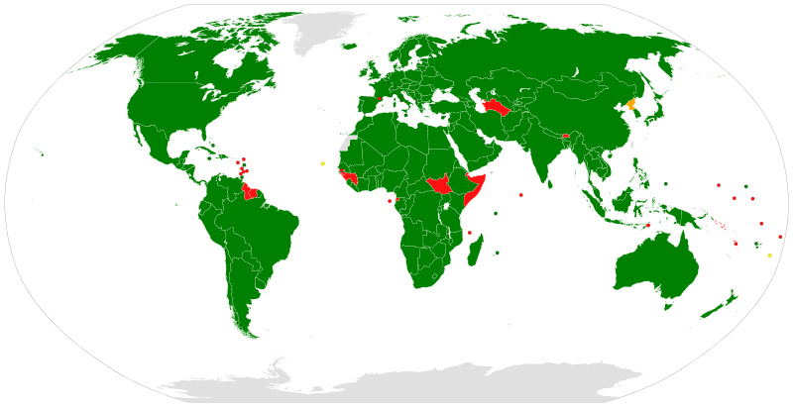

IAEA member states as of February, 2014
Member states
Approved states: Brunei, Cape Verde and Tonga
Withdrawn membership: North Korea
Non-members

After the 2011 incident in Japan, IAEA stated that its international role in surveillance needs to be increased. Having third parties interfere with inspections of power plants or communicating with NPPs is less effective and does not promote as much safety and security for the public, which is a fundamental topic for the organization.

The Non-Proliferation Treaty
The mother of all legitimate nuclear trade these days is without a doubt the NPT. The non-proliferation (non-spread) treaty (NPT) was brought forth in 1968 by Ireland and Finland, and carried into force in 1970. The objective of the treaty is to limit the spread of nuclear weapons all across the globe, and currently has 189 member states. Five of the treaty members (USA, Russia, U.K., France and China) are recognized nuclear warhead states (NWS) and received special permissions to join into the treaty although obtaining nuclear warheads.
The main points of provision are as follows:
- prevent the wider dissemination of nuclear weapons
- make peaceful applications of nuclear technology widely available
- promote cessation of the nuclear arms race and move toward nuclear disarmament
- seek to achieve discontinuance of test explosions of nuclear weapons
This led to an immediate separation of the world´s nations into two groups; the nuclear weapon states (NWS) and the non-nuclear weapon states (NNWS).
Key provisions in the NPT were:
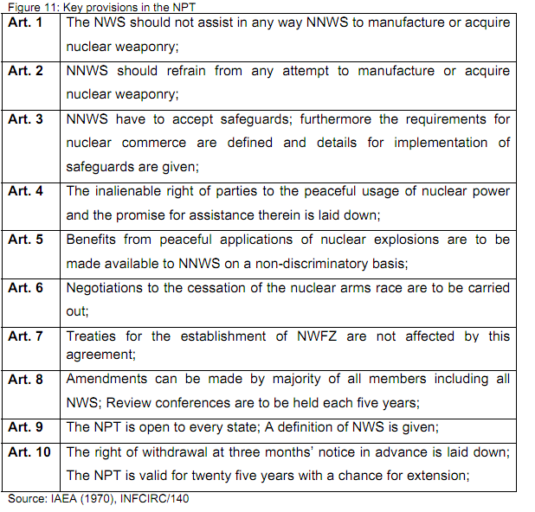
Some critics argue that the issue, not considered enough in the NPT, is the distinction between nuclear latency and nuclear hedging. Nuclear latency can be described as inadvertence, where a particular state has basic capabilities to produce fissile materials for nuclear weapons but has no foreseeable intentions of doing so. Such country can as well be called a virtual nuclear state. Whereas nuclear latency is therefore unintentional, nuclear hedging is a deliberate national strategy, aimed at acquiring nuclear weapons technology relatively quickly. This can result in virtual nuclear race that has a possibility to consequently escalating into real arms race, resulting in break- outs from the NTP, in the worst case scenario even nuclear war. This is where politics tends to step in to fill the scientific gap in the NTP provisions, ruling one state`s actions as latent and other deliberate, depending on the current ally- foe axis. Consequently, this can also affect the nuclear commerce process for selected countries, following the trends shown in the latency/hedging deliberation. This is very evident if we turn our focus to the turnkey nuclear technology countries: for instance, Japan and Germany are tolerated for having such possession (therefore, we consider their capabilities as nuclear latency), while Iran is currently in the global spotlight and in the midst of very tough international deliberations and negotiations to be given the same opportunity (and is therefore suspected of nuclear hedging, although we are talking about the same technologies).
Pakistan and India, which are non-signatory countries to the treaty, are confirmed NWS but have declined signing the treaty. The two countries combined carry an estimated 250 nuclear warheads, and do not intend to sign the treaty in the near future according to the India´s External Affairs Minister Pranab Mukherjee who in 2007 stated: "If India did not sign the NPT, it is not because of its lack of commitment for non-proliferation, but because we consider NPT as a flawed treaty and it did not recognize the need for universal, non-discriminatory verification and treatment”. Signing the treaty would mean that both countries would have to give up their nuclear defense capabilities. That is why many believe that the current non- proliferation framework is improper, because it allows some countries to enjoy the fruits of nuclear technology while hinder this process for others, ruled not trustworthy and dangerous. This is particularly hypocritical considering the fact that the only country that has ever deployed a nuclear weapon on another country has a very prominent and patronizing role in the current nuclear non- proliferation framework.
North Korea, who in 1985 ratified the treaty, violated it by continuance of nuclear warhead production, which resulted in their 2003 withdrawal from the treaty. This has led to further international instability with regards to recent confrontations between South and North Korea in 2010. The nuclear threat North Korea still poses the world is inevitable.
Libya is a country which has been under investigation for many years concerning alleged of secret nuclear warhead development programs. In 2003, together with USA and UK, Libya allegedly commenced a WMD elimination program. In 2011, when instability broke in Libya, further importance on the subject was brought forward. By 2012, when Gaddafi was ousted and killed by the rebel forces, very possibly backed by western intelligence agencies, a new era for the elimination program began. By January 2014, new government in Libya destroyed the entire category 1 chemical weapons stockpile under the supervision of Organization for the Prohibition of Chemical Weapons. Also, in 2012, IAEA announced Program framework 2012-2017, designed to use nuclear technology and resources for economic development.
(Iran is part of the NPT, but was found in non-compliance with its NPT safeguards agreement and the status of its nuclear program remains in dispute and so does its membership with the NPT. Worth mentioning is a breakthrough, reached in November, 2013, when Joint Plan of Action was signed in Geneva by Iran, US, Russia, China, France, United Kingdom and Germany. The pact called for a short- time freeze of sections of the Iranian nuclear programme, in exchange for decreased economic sanctions that were imposed on the country. In addition to this interim agreement there was also one signed between Iran and the IAEA that established a framework for cooperation in resolving issues, concerning the Iranian nuclear programme. All of the above mentioned does not mean we are oblivious to the fact that the process of hindering the Iranian nuclear programme has wider geopolitical implications, stretching from Israel, Riyadh to Wall Street.)
After its formation the Unites States and the Soviet Union agreed on various protocols to guarantee a non-nuclear attack pact, which is still in force today.
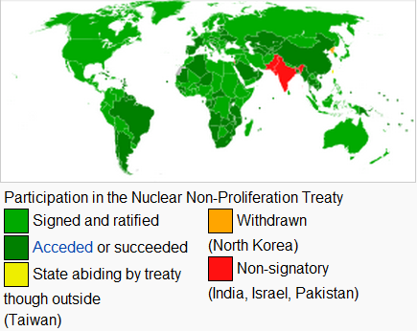Source: www.iaea.com
To ensure that the NPT is respected by all member states, a conference to the treaty is held every five years. (A meeting was held in 2010 in New York, after having failed to meet in 2005.) At the meetings, discussions are held regarding the future of the NPT and any related measures that need to be taken.
The introduction of the NPT in turn led to two additional treaties of great international importance; the Limited Test Ban Treaty, and UN´s creation of the NWFZs (Nuclear-Weapon-Free Zone). It also reflected on the underlying issue of continued production of fissile materials; resulting in the tryouts to ban the production altogether with a Fissile Material Cut-Off Treaty.
Limited Test Ban Treaty: Treaty that prohibits all tests of nuclear weapons except those conducted underground. U.S.-Soviet test-ban talks began after concerns arose in the 1940s and '50s about the dangers of radioactive fallout from above-ground nuclear tests as well as an attempt to slow down the nuclear arms race. It was signed and ratified in 1963 by USA, U.K. and the Soviet Union, and today contains signatures from 116 countries.
(This was later followed by U.N.´s comprehensive test ban treaty (CTBT) which states that no nuclear detonations are allowed. The treaty was adopted in 1996 but has not come into effect yet. Also, most prominent nuclear force, USA, has still not ratified the Treaty although the Obama administration repeatedly called for support of the Treaty in the Senate. However, 162 countries have ratified it and are obeying its points of conduct. Until the treaty enters into force, the organization behind the proposed legal framework is the so called Preparatory commission for the CTBT. The main purpose of the Preparatory commission, which is based in Vienna, Austria, is to promote the treaty and to establish a proper verification regime, so once the treaty enters into force everything will be prepared and operational. The current system within the CTBT for global nuclear test monitoring has proved to be far more efficient than anticipated just a decade ago, and furthermore, proved to be a good addition to the existing tsunami warning centers. It is believed that the entry of the CTBT in force would increase the global leverage, needed to contain the North Korean nuclear programme, deter Iranian leadership and their ambitions in the nuclear strengthening, reduce nuclear tensions between India and Pakistan on the one hand and China and India on the other and therefore help to enhance the stability and security in the Asian region.)
NWFZ: This agreement with the United Nations bans the use, development or deployment of nuclear weapons in a given area. This, however, does not cover international waters or transit of nuclear missiles through space, nor does it count small regions or countries which have forbidden nuclear weapons by national law, i.e. Austria´s “Atomsperrgesetz” which came into force in 1999. There are five major NWFZ: Latin America and the Caribbean, South Pacific, Southeast Asia, Africa and Central Asia. In addition to the above recognized legal vacuum, there are also separate treaties banning the deployment of nuclear weapons in Antarctica, Mongolia, on the sea-bed and outer space.
There has been an interesting turmoil concerning NWFZ. On the one hand, states that pushed for the NWFZ to become applicable for their region, argue that they are trying to win the geopolitics of nuclear testing sites, meaning that the whole nuclear weapons process was to a large extent dominated by the Northern- hemispheric countries, testing their weapons in the supposedly “empty” South. On the other hand, states that hinder the process argue that this is just a clever way to prevent the Third world states to enjoy the benefits of the technology the North has been enjoying for decades. This is another good example of how difficult it is to reach an agreement on the international level on seemingly clear issues such as national security and safety of the planet and its inhabitants. But, as always, the important part is also the interests and the domestic situation of the given actors in the global community.
Fissile Material Cut- Off Treaty: Since 1993, when the UN GA adopted a resolution 48/75 with consensus, there was a clear recommendation to establish a non- discriminatory, multilateral treaty banning the production of fissile materials (the key ingredient to produce a nuclear weapon). However, the conclusion to these efforts is still pending because many nuclear weapon states have major discrepancies on the treaty`s substance and therefore the treaty has yet to be negotiated and its terms have yet to be defined. To most difficult ones to reach consensus on are, to name just a few:
- The extension of the treaty: the US and UK do not wish to extend the framework on the exiting fissile material stockpiles; while others, like Pakistan, see this as unacceptable and as a threat to Pakistani national security (clearly signaling towards the rival neighboring nuclear India);
- The scope of the treaty: some feel that in addition to banning the production of plutonium and highly- enriched uranium, the treaty should also ban materials like trinium, which is used as an amplifier for the strength of nuclear weapons; others include elements like depleted and natural uranium, neptunium, curium, californium and americium (though not fissile materials, they are also used in the nuclear weapons programmes)
- Verification system under the treaty: the most substantial issues with the proposed incorporated verification mechanism had the US under the Bush administration that lobbied for the ad hoc system of verifications. However, under Obama the support for the treaty`s idea grew considerably. But since the treaty and its provisions have not yet been established, much less ratified, it is unclear what the future position of US on the verification matter will be;
- Including mechanisms for the management of existing fissile material;
- Intertwining other similar issues to the treaty: Russia and China both wish to incorporate this treaty into the larger frame of a prevention of arms race in the outer space.
Such differing positions on the matter have for now prevented to fully draft and introduce a comprehensive treaty and it is not clear how the events will unravel in the future. The biggest issue seems to be the NWS states themselves (since others already comply to the idea of this treaty through the NTP provisions) and other states that are producing large amounts of fissile materials for non- military purposes, such as Japan and Canada. And when it comes to such contradictory power- plays, global politics is known to fail time and time again.

7-The Nuclear Commerce Regime
In the nuclear field non-proliferation and commerce are two subjects not easily separable. An export control regime has two purposes: it has to stop the world wide proliferation of sensitive nuclear material or technology through the establishment of clearly defined norms and at the same time it should not hinder trade in this sector. The establishment of a working and relevant non- proliferation regime within the nuclear commerce has been challenging not just due to the pure nature of this issue, but also because of the changing global market forces and rapid technological improvements. The increase of states that can act as traders of sensible nuclear technology is consequently creating a much more diverse global playground that has to be monitored. Another, interrelated factor is the process of globalization, that is effecting military and peaceful nuclear commerce efforts; diversifying source of funding into also largely private stakeholders represents another complex factor. Combined with the rapid evolvement of communication technologies, that make it all the more easier to share the know- how on the matter and the additional technological leap in nuclear sector as well, the nuclear commerce regime has to cover manifold and complex issues, while at the same time prove efficient when it comes to the basic security considerations.
In other words; a nuclear export control regime means a struggle between the demands for security and the free flow of goods. Such trade has been explicitly allowed for in the NPT. Unfortunately, just as the nuclear commodity market has not left been entirely to free market forces, the same goes for the nuclear non- proliferation and the nuclear commerce regime: many of the decisions made are still more (geo)political than economic/commercial. Nevertheless, the system of multilateral export measures has greatly evolved over time. Before the conclusion of the non-proliferation treaty the intention to set up rules had to come entirely from an individual state, whereas in the time after the NPT this was shaped by multilateral incentives; the most important ones are underlined in the featuring Table, and they will also be further discussed on the following pages:
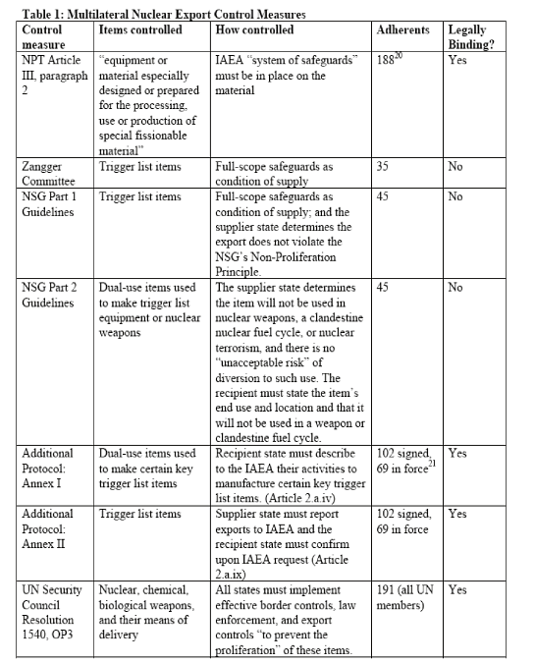

The IAEA framework

We have already discussed the immense role that IAEA has taken upon itself; to play the global nuclear watchdog. Now, we also have to discuss the three most important pillars in the IAEA framework that are impacting the working nuclear commerce regime and its organization. These are:
- Safeguards and Verifications, for they represent the control mechanism for countries to oblige to the agreed upon safeguards and a way to monitor adherence of member states to the rules;
- Safety and Security, for they represent all the necessary procedures to be taken in the field of nuclear commerce and the final decision if a certain country is suitable to be a part of nuclear commerce and under which conditions;
- Science and Technology, for they represent all the newest scientific breakthroughs to reckon with for better control of nuclear commerce and less chance to converting the purchased commodities into military capabilities.

The Zangger Committee

The ZC is the oldest of the currently existing nuclear export control measures. It is probably also the legally most legitimate control structure.
“The committee is named after its first Chairman, Prof. Claude Zangger, and was formed following the coming into force of the Nuclear Non-Proliferation Treaty, to serve as the "faithful interpreter" of its Article III, paragraph 2, to harmonize the interpretation of nuclear export control policies for NPT Parties.
The Committee has been focusing on what is emphasized in Article III.2 of the Treaty by "especially designed or prepared equipment or material for the processing, use or production of special fissionable material." The Zangger Committee maintains a Trigger List (triggering safeguards as a condition of supply) of nuclear-related strategic goods to assist NPT Parties in identifying equipment and materials subject to export controls.
Today the Zangger Committee has 38 members including all the nuclear weapon States, and the Trigger List and the Zangger Committee's understandings are regularly published by the IAEA (Intl. Atomic Energy Agency).
(Current Chairman, since November 2010, is Mr. Shawn Caza of the Canadian Mission in Vienna.)

The Nuclear Suppliers Group

The NSG was founded in 1974 in response to the Indian nuclear test earlier that year, and they describe themselves as follows:
“The Nuclear Suppliers Group (NSG) is a group of nuclear supplier countries which seeks to contribute to the non-proliferation of nuclear weapons through the implementation of Guidelines for nuclear exports and nuclear related exports.
The NSG Guidelines are implemented by each Participating Government in accordance with its national laws and practices. Decisions on export applications are taken at the national level in accordance with national export licensing requirements.”
Therefore, the most important subjects, coordinated by the NSG, are national export controls on nuclear equipment, nuclear- related materials and technology and the specified dual use items. The controls are fully compliant with the NPT and, what is also important, member states of the NSG include some of the major developing countries, such as Argentina, Brazil, China, Kazakhstan, Mexico, South Africa and Turkey.
Today the NSG guidelines are being published by the IAEA as INFCIRC/25434. A consultative body was created in order to consult on issues associated with it. One of the most interesting of the published guidelines is a reference to the establishment of multinational control over sensitive nuclear programs, or as written “If enrichment or reprocessing facilities, equipment or technology are to be transferred, suppliers should encourage recipients to accept, as an alternative to national plants, supplier involvement and/or other appropriate multinational participation in resulting facilities. Suppliers should also promote international (including IAEA) activities concerned with multinational regional fuel cycle centers”.

The most important objective in any of the multilateral approaches in the nuclear safeguards field is to establish technical and institutional barriers that would prevent states to misuse enrichment and reprocessing capabilities. Hence, the less control individual state has over such capabilities, the harder it will be to misuse them. Of course none of the barriers can be totally effective, but a multilateral approach to the matter can make misuse more difficult to conduct, leaving a substantially larger window of time opened for international intervention. Of course, such arrangements are accepted with distrust due to the abuse of “international interventions”, particularly on the side of the US.

What is optimistic is that examples of such multinational approach already exist in reality: such as European Enrichment Group and the International Uranium Enrichment Centre in Siberia. The latter was established by Russia, with the ultimate goal of enabling equal possibility for all countries to benefit from atomic energy, with ensuring the access to relevant materials and technology.

Rallying enough support for the process of multilateralization of the proliferation- sensitive stages of the nuclear fuel cycle will no doubt be challenging, but the practical precedents, such as the above mentioned Uranium Enrichment Centre and the European Enrichment Group, hold optimistic prospects for the future.

The Wassenaar arrangement

The Wassenar arrangement (WA) is a multilateral export control regime, aimed at contributing to regional and international security and stability by promoting and advocating better transparency and responsibility in transfers of dual- use technologies as well as conventional arms. The Arrangement has 41 participating parties, but since it is not a treaty, it is not legally binding. Each member state obliges to the arrangement in accordance with their national law and policies which means that in the end, the decision to permit or deny the transfer of certain technology/weapons is entirely on the state level. But in compliance with the arrangement, the participating states seek to ensure that transfers of conventional weapons/dual-use technologies do not encourage or speed up the process of building military capabilities.
The WA regularly publishes a list of special dual- use goods and technologies and ammunition list that are preferable to be a subject of export control regime. The last such list has been published in 2013 by the decision- making and governing body of the WA, the Plenary, consisting of members from each participating state.
Although not legally binding, the WA still represents a set of standards of good practices regarding parts of the significantly larger overall nuclear commerce regime.

UN Security Council Resolution 1540
The United Nation´s Security Council Resolution 1540 was adopted in 2004 and established binding obligations on all UN member states under Chapter VII of the UN Charter for the first time to take and enforce effective measures against the proliferation of weapons of mass destruction, their means of delivery and related materials. All of the UN member states were required to adopt and enforce laws as well as other measures of domestic control.
Resolution 1540 also forms part of series of resolutions on terrorism adopted by the UN Security Council after the terrorist attacks against the United States in 2001, and has therefore been a subject of controversy in many countries due to the agenda designed after US´s preferences. What makes Resolution 1540 so special is that it is only the second time that the Security Council has used its power to make a decision which is legislative in its nature. As a consequence, all members to the United Nations have to adhere to these newly created commitments and are thereby obliged to send their report to the 1540 Committee.

8-Conclusion

The commerce for nuclear power has been enveloped in secrecy ever since the beginning of the applied nuclear/atom physics and its experiments – after the WWI in Europe and during the WWII in the US. Its future is surely not yet determined. The non-proliferation framework and other efforts to restrict the number of users and to divert it to the peaceful usage only as well as the efforts to enforce it (including the later CTBTO monitoring of compliance mechanism) has been of highest priority ever since the beginning of nuclear tests. Deployment of the nuclear bomb seven decades ago on Hiroshima and Nagasaki, as well as the accidents in the nuclear power plants (such as ‘3 mile’, Chernobyl and recent Fukushima) have surely darkened the public image regarding the atomic power. They have also shown the need for closer international cooperation and collaboration, combined with transparency and accountability. Especially the Fukushima accident shows that the world needs a new balance between national and international interests concerning nuclear energy.
Another point for nuclear fear is the possible double use of the technology. With global scares in the past, weapons of mass destruction are a good reason for why many of us take a step back when considering nuclear power. These negative elements make it difficult for nuclear power to make a breakthrough in the energy industry however, in recent years a vast amount of countries have signed contracts for construction of nuclear power plants. France in turn sets a favorable example for countries getting involved in nuclear power, with its almost 80 percent reliance on atomic energy. This is a very good example that should be mimicked by many more in the following decades if we are really determined to introduce a green growth and more of the mankind towards the decarbonized future community. Another point in favor of increased nuclear activities is the availability of uranium resources and the emerging possibility to use thorium as a fuel, another fairly abundant natural resource. Quite paradoxically, the rise of uranium prices has not harmed the industry, but rather helped to attract more interest in the exploration of new deposits. The questions of utmost importance for the future of the nuclear industry will be whether or not:
- The nuclear industry will be capable of closing the emerging energy generation gap at a competitive price.
- The current framework in the field of nuclear commerce can function as a suitable non-proliferation tool, and specifically in the field of double use technology.
- The nuclear non-proliferation framework hinders the development of nuclear commerce.
- The industry can provide proof of public safety regarding the management of the residual waste as well as the power plants themselves.
Asia, with its huge economy which continues to grow, is an enormous market for nuclear power, but knowing that many parts of eastern Asia is located in an earthquake sensitive zone puts a different perspective on it all when looking at the Fukushima plant in 2011. The most important lesson learnt should be the upgrade of emergency power generators that will also be resistant to a tsunami hit, since the back-up system at nuclear power plants all over the country (including the Fukushima power plant) proved to be (only) earthquake- proof.
Most probably a complete merger between the Zangger Committee and the NSG could be highly beneficial for the future and security of nuclear power; this way the support, backing up the industry, would have more effect as well as authority than if they work as two individual organizations. Although the IAEA was created as a nuclear watchdog, its competence can in reality only be realized to a certain extent. The IAEA has a limited budget to work with which creates some restrictions for the organization`s reach of its operations. (This is highly imperfect since the stakes are far too high to not be controlled to 110 %!)
Secondly, the IAEA´s powers in safeguard related issues need to be adapted to recent development and industry improvements. Having closer ties between IAEA, The Zangger Committee and the Nuclear Suppliers Group would definitely create stronger global co-operation, enhanced national control systems and help to free additional donations because of better coordinated fund-raising activities.
The nuclear future relies heavily on public as well as political support. Over the last few decades initial steps in the right direction can already be identified and this is shown in the amount of new projects and political incentives in recent times. Politicians’ responsibilities to inform the public about nuclear power and its potential are not being executed efficiently which is why many of us are against nuclear power. By providing the public with accurate knowledge and impressive numbers, people are more likely to make educated conclusions. This will then, in turn, make nuclear power more socio- economically suitable and through that, also more acceptable in the politico- military frame.
The new Generation III plants offer a completely new dimension for nuclear commerce, with its highly efficient plants and with less failure risk. However, another nuclear disaster within the next few years could perhaps permanently damage the industry in developing to its full capacity.
Reforms in energy sources can only happen on a gradual basis. When discussing nuclear power it is of utmost importance to bring real facts and figures in comparison to other energy alternatives to get a clear overview of the situation. Nuclear will not be able to reform the energy market or even play a key role, however by teaming up with renewable forms of energy in an attempt to create a low emission energy mix represents the most realistic and viable option we have if we are interested in introducing a new, (preferably) fossil- fuels free primary energy mix. In this respect nuclear energy could provide something renewables are still struggling with: base load capacity.
At the end of the day, humanity should strive towards an energy source which is totally renewable, efficient, economically sustainable, and environmentally friendly. It is a decisive civilizational battle. The pattern of green-house gas emissions and to it related climate change should be challenged. At a present stage of our technological breakthrough, this will be impossible to achieve without serious deployment of nuclear energy for pacifistic purposes, including the increased investment into the ITER project for fusion reactors. And while the ultimate answer to life, the universe and everything may not be 42, it should be somewhere close to a new, balanced and more harmonic relationship between humanity and nature. Not to go into this change rapidly, radically and chaotically, but with a clear head, right information and a little more altruistic approach to our planet.

LIST OF REFERENCES

- The UN Development Program: Human Development Report 2013 (IHD Index, Poverty and Inequality);
- Bajrektarevic, A. (2010), Arctic and Antarctic – Security Structures Surrounding the Two Poles, Geopolitics, History and International Relations 2 (2): 218-219, Addleton Publishers 2010
- Bajrektarevic, A. (2012), Geopolitics of technology and the hydro- carbon status quo, Geopolitics of Energy, CERI Canada 34(9) 2012
- Bajrektarevic, A. (2012), Climate change: Humans remain the same, Addleton Academic Publishers, NY, CRLSJ 4(1) 2012
- Bajrektarevic, A. (2013), Is There Life After Facebook – Geopolitics of Technology and other Foreign Policy Essays, Addleton New York
- IAE, International Energy Agency – World Energy Outlook 2014, /Part B/, (Preliminary version, to be released in November 2014), IEA Paris 2014;
- The UN Framework Convention on Climate Change, UN FCCC/1992/84, GE.05-62220 (E) 200705 and the Kyoto Protocol to the UN FCCC of 1998, UN Office of Legal Affairs;
- Future Conflict Studies (2009), Understanding Human Dynamics, Report of the US Defense Science Board Task Force, March 2009;
- Bajrektarevic, A. (2012), Why Kyoto Will Fail Again, Geopolitics of Energy, 34 (1), CERI Canada 2012
- The Rio Declaration on Environment and Development (1992), UN CED – Earth Summit, Rio de Janeiro, 1992
- World Bank (2010), World Development Report 2010: Development and Climate Change, WB Publications
- World Bank (2014), World Development Report 2014: Risk and Opportunity – Managing Risk for Development, WB Publications
- OECD (2014), OECD Economic Outlook (Preliminary Version, May 2014), OECD Publications
- WWF, GFp, IoZ and ESA (2012), Living Planet: Biodiversity, biocapacity and better choices, Report 2012
- Mumford, L. (1970), The Myth of the Machine – Pentagon of Power (Technics and Human Development Vol.2), Mariner Books (Ed. 1974)
- Dresner, S. (2002), The Principle of Sustainability, EarthScan London
- Smith, L.C. (2010), The World in 2050 – Four Forces Shaping Civilization’s Northern Future, Dutton (by Penguin group)
- Engdahl, F.W. (1992). A century of war: Anglo- American Oil Politics and the New World Order. Wiesbaden: Dinges&Frick.
- Engdahl, W.F. (2009). Full spectrum dominance: Totalitarian Democracy in the New World Order. Wiesbaden: Dinges&Frick.
- Dodds, K. (2005). Global geopolitics: a Critical Introduction. Essex: Pearson Education Limited
- Lochbaum, D., Lyman, E., Stranahan, S. (2014). Fukushima: The Story of a Nuclear Disaster. New York: The New York Press
- Petrangeli, G. (2006). Nuclear Safety. Oxford: Elsevier Butterwirth- Heinemann
- Gaffigan, M. (2009). Nuclear waste management. Washington D.C.: GAO
- Maize, K. (2014). Worldwide nuclear commerce. Power mag.
- Murray, R.M and Holbert, K.E. (2014). Nuclear energy: An Introduction to the concept, systems and application of nuclear processes. Oxford: Elsevier inc.
- Ross, P. (2014). Could Californium Solve Nuclear Energy`s biggest problem? The Business Times.
- Tarantola, A. (2013). The Future of Nuclear Power runs on the Waste of Nuclear Past. Gizmodo.
- The New Scientist. (2011). Cut nuclear power`s umbilical cord to the military. n.a.a.
- Pickering, T.R. (2013). U.S. Leadership Needed to Prevent Nuclear Testing by North Korea, CTBTO Spectrum nbr. 20: 7-8.
- Fusion Energy Foundation. (1979). Fusion. (The piece received the Freedoms Foundation Award for outstanding Journalism)
- Armstrong, J.S., Green, K.C. and Soon, W. (2013). The science fiction of IPCC climate models- OpEd. Eurasia Review.
- Driessen, P. (2014). Just assume we have a climate crisis. Eurasia Review.
- Sovacool, B.K. (2011). Contesting the Future of Nuclear Power: A Critical Global Assessment of Atomic Energy. Singapore: World Scientific Publishing Co. Pte. Ltd.
- Stanton, N.A. (1996). Human Factors in Nuclear Safety. London: Taylor and Francis Ltd.
- Sagan, S.D. and Waltz, K.N. (2002), The Spread of Nuclear Weapons: A Debate Renewed, NY W.W. Norton
- Waltz, K.N. (2012), Why Iran should get the Bomb – Nuclear Balancing would mean Stability, Foreign Affairs Magazine 91 (4) 2012
- Polič, M. (2013), Ljudje in jedrska energija: od navdušenja do stigme (People and Nuclear Energy: from Enthusiasm to Stigma), Ljubljana: Filozofska fakulteta.
- Lubi, D. (1999), Jedrsko širjenje po hladni vojni (Nuclear Proliferation after the Cold War), Ljubljana: Fakulteta za družbene vede
- Bajrektarevic, A. (2014), 25 years after 9/11 – How Many Germanies should Europe have?, Modern Diplomacy.

ADDITIONAL REFERENCES:
EIA report, 2009
WASHINGTON STATE DEPARTMENT OF HEALTH (2003), p.2
U.S. EIA 2009
IEA 2010 (n.p.a.)
WNA – 2010

NEA (2006), p.6
Stockinterview.com (2006), p.128
Georgewbush-whitehouse.archives.gov
ISIS (Institute for science and International Security) – June, 2004
US Department of State 2011, Annual report

Preparatory Commission for the Comprehensive Nuclear-Test-Ban Treaty Organization (2010)
www.zanggercommittee.org
http://www.state.gov/t/isn/c18943.htm
CTBTO 2013
Federation of American scientists 2014

European Commission: Futurium 2014
http://www.iter.org/
Enerdata Global Energy Statistical yearbook 2014

EIA International Energy Outlook 2013
BP Energy Outlook 2013
Global Footprint Network 2012
International Panel for Climate Change Assesment Report 2013
United Nations University 2011
Centre for Global development 2013
World nuclear industry status report 2012
Report from the Centre for nuclear non- proliferation and disarmament 2013
World Nuclear Association 2014
World nuclear Association 2012
UNFC (United Nations Framework Classification for Fossil Energy and Mineral Reserves and Resources) 2013
World Nuclear report 2012
European Commission 2012
Foratom 2014
Arms control 2013
Arms control 2014
http://www.ctbto.org
IAEA 2012
http://www.wassenaar.org
IAEA/NEA Red book on Uranium: Resources, Production and demand 2014
World Nuclear Association Report on Lifecycle Emissions from Electricity Generations 2011

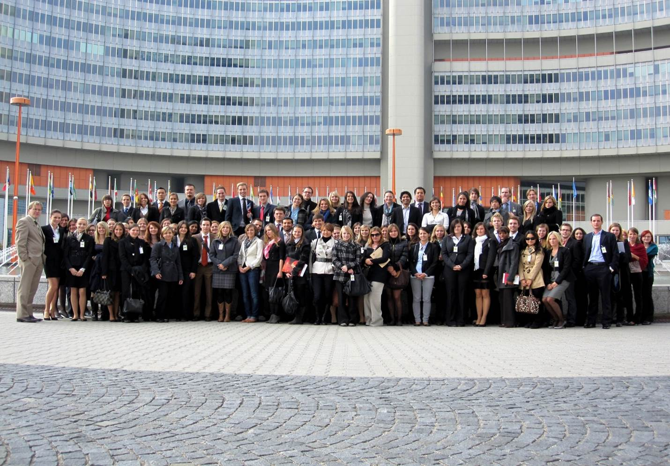

Murray and Holbert (2014), p. 217-218
Murray (2001), p. 9
Murray and Holbert (2014), p. 11-12
Washington State Department of Health (2003), p.2
IAEA 2014
World Nuclear Association 2014
Resources available and amount exploited differs vastly
Bajrektarevic (2012), p.1)
European Commission: Futurium 2014
http://www.iter.org/
New Sceintist (2014), n.a.a.
CTBTO 2013
Prepared Testimony for the U.S. Senate Foreign Relations Committee regarding the Moscow Treaty, 2002
Dodds (2005), Engdahl (2010)
The data on the actual number of nuclear weapons differs vastly due to the national- security related secrecy of the subject.
Federation of American scientists 2014
This view can be challenged on many levels, we are just going to mention a few most important ones: all the Nuclear weapon states developed their nuclear weaponry before launching their nuclear energy initiatives; so in a spirit of what came first, chicken or the egg, nuclear weapons take the lead; most of the countries embarking upon nuclear energy were developing these capabilities solely for this goal; although having capabilities to operate with civil nuclear energy does have certain relief considering time consumption and know- how, diverting civil programme into a nuclear one is very costly (not just logistically speaking but also considering the political price); hence, most countries would not embark upon time consuming and costly process of diverting peaceful nuclear programmes into military and would instead start up a military programme in the beginning (Lubi (1999), p. 27)
Fusion energy foundation 1979.
As the most traded commodity in the world, the final consumer price of oil is always determined (largely influenced) by the NY and London city. This was a case, despite the delivery interruptions, even in 1973.
Another interesting thing about the US dollar currency is that it is not really state owned. If we look at the banknote closely, it says very clearly Federal Reserve note, which is a private, not state owned entity.
Engdahl (1992), p.158
Bajrektarevic (2013), p. 4
OECD 2012
Enerdata Global Energy Statistical yearbook 2014
EIA International Energy Outlook 2013
U.S. EIA 2009, Nuclear energy today 2012
IEA 2010
BP Energy Outlook 2013
Global Footprint Network 2012
Driessen (2014), n.p.a.
Green, Armstrong and Soon (2013), n.p.a.
International Panel for Climate Change Assesment Report 2013
United Nations University 2011
Centre for Global development 2013
IEA 2011
World nuclear industry status report 2012
Maize (2014)
Report from the Centre for nuclear non- proliferation and disarmament 2013
IAEA 2014
Report from the Centre for nuclear non- proliferation and disarmament 2013
Polič (2013), p. 91
Ross (2014), Gaffigan (2009) and Tarantola (2013)
Georgewbush-whitehouse.archives.gov
European Commission 2012, Foratom 2014
At the time of finishing this article, the new European Commission has just been established, hence we cannot (yet) evaluate their future decisions and policies.
A study conducted on MIT shows that to make building of a new nuclear plant cost- effective, one must impose a carbon tax of nearly 200$ a ton on the conventional power plants to get the necessary funds.
Sovacool, B.K. (2011), p. 6-12
WNA – 2010
Report from the Centre for nuclear non- proliferation and disarmament 2013
World nuclear Association 2012
NEA (2010), p.6, World Nuclear Association 2014
Stockinterview.com (2006); p. 96, World Nuclear Association 2014
WNA (2007), n.p.a.
UNFC (United Nations Framework Classification for Fossil Energy and Mineral Reserves and Resources) 2013
Stockinterview.com (2006), p.128
World Nuclear Association 2012
World Nuclear Association 2014
World Nuclear Report 2012
OECD 2012
World Nuclear Association 2014, Petrangeli (2006).
Petrangeli (2006), p.90.
Lochbaum/Lyman,/Stranahan (2014), p. 84
Stanton (1996), p.5
Chellaney (2007)
Bailey/Guthrie/Howlett/Simpson (2000), p.3
www.iaea.org
IAEA - 2011
In this sense, there are two types of nuclear proliferation; material- technical and political proliferation. Whereas material- technical proliferation is a necessary basis for creating a nuclear weapon (having all the required materials and technology), that does not necessarily imply this happening as the final result. Another component is political proliferation, which means a rational decision of the political apparatus to create a nuclear weapon, taking into account different foreign and domestic political factors, also not neglecting the security and economic consideration. As a result, nuclear proliferation is predominantly a political occurrence. (Lubi (1999), p. 22)
Report from the Centre for nuclear non- proliferation and disarmament 2013
ISIS (Institute for science and International Security) – June, 2004
Arms control 2013
US Department of State 2011
http://www.ctbto.org
Preparatory Commission for the Comprehensive Nuclear-Test-Ban Treaty Organization (2010), Pickering (2013), p. 7—8
Arms control 2014
Arms Control 2013
Blackford (2005), p.5
www.zanggercommittee.org
NSG (2001), p. 7
IAEA 2012
http://www.wassenaar.org
EUJA
Vertic (2007), n.p.a.

